**VISVESVARAYA TECHNOLOGICAL UNIVERSITY**

**“JnanaSangama”, Belgaum -590014, Karnataka.**



**LAB REPORT**

**on**

**Artificial Intelligence (23CS5PCAIN)**

***Submitted by***

**Siddhant Sawhney (1BM23CS327)**

***in partial fulfillment for the award of the degree of***

**BACHELOR OF ENGINEERING**

***in***

**COMPUTER SCIENCE AND ENGINEERING**



**B.M.S. COLLEGE OF ENGINEERING**

**(Autonomous Institution under VTU)**

**BENGALURU-560019**

**Aug 2025 to Dec 2025**

**B.M.S. College of Engineering,**

**Bull Temple Road, Bangalore 560019**

(Affiliated To Visvesvaraya Technological University, Belgaum)

**Department of Computer Science and Engineering**



**CERTIFICATE**

This is to certify that the Lab work entitled “Artificial Intelligence (23CS5PCAIN)” carried out by **Siddhant Sawhney (1BM23CS327)** who is bonafide student of **B.M.S. College of Engineering.** It is in partial fulfillment for the award of **Bachelor of Engineering in Computer Science and Engineering** of the Visvesvaraya Technological University, Belgaum. The Lab report has been approved as it satisfies the academic requirements in respect of an Artificial Intelligence (23CS5PCAIN) work prescribed for the said degree.

|  |  |
| --- | --- |
| Seema Patil  Assistant Professor  Department of CSE, BMSCE | Dr. Kavitha Sooda  Professor & HOD  Department of CSE, BMSCE |

**Index**

|  |  |  |  |
| --- | --- | --- | --- |
| **Sl.**  **No.** | **Date** | **Experiment Title** | **Page No.** |
| 1 | 30-9-2024 | Implement Tic –Tac –Toe Game  Implement vacuum cleaner agent | 4-12 |
| 2 | 7-10-2024 | Implement 8 puzzle problems using Depth First Search (DFS)  Implement Iterative deepening search algorithm | 13-24 |
| 3 | 14-10-2024 | Implement A* search algorithm | 25-29 |
| 4 | 21-10-2024 | Implement Hill Climbing search algorithm to solve N-Queens problem | 30-33 |
| 5 | 28-10-2024 | Simulated Annealing to Solve 8-Queens problem | 34-36 |
| 6 | 11-11-2024 | Create a knowledge base using propositional logic and show that the given query entails the knowledge base or not. | 37-40 |
| 7 | 2-12-2024 | Implement unification in first order logic | 41-48 |
| 8 | 2-12-2024 | Create a knowledge base consisting of first order logic statements and prove the given query using forward reasoning. | 49-51 |
| 9 | 16-12-2024 | Create a knowledge base consisting of first order logic statements and prove the given query using Resolution | 52-59 |
| 10 | 16-12-2024 | Implement Alpha-Beta Pruning. | 60-62 |

Github Link:

<https://github.com/siddhantsawhney327/AI->

**Program 1**

Implement Tic –Tac –Toe Game

Algorithm:

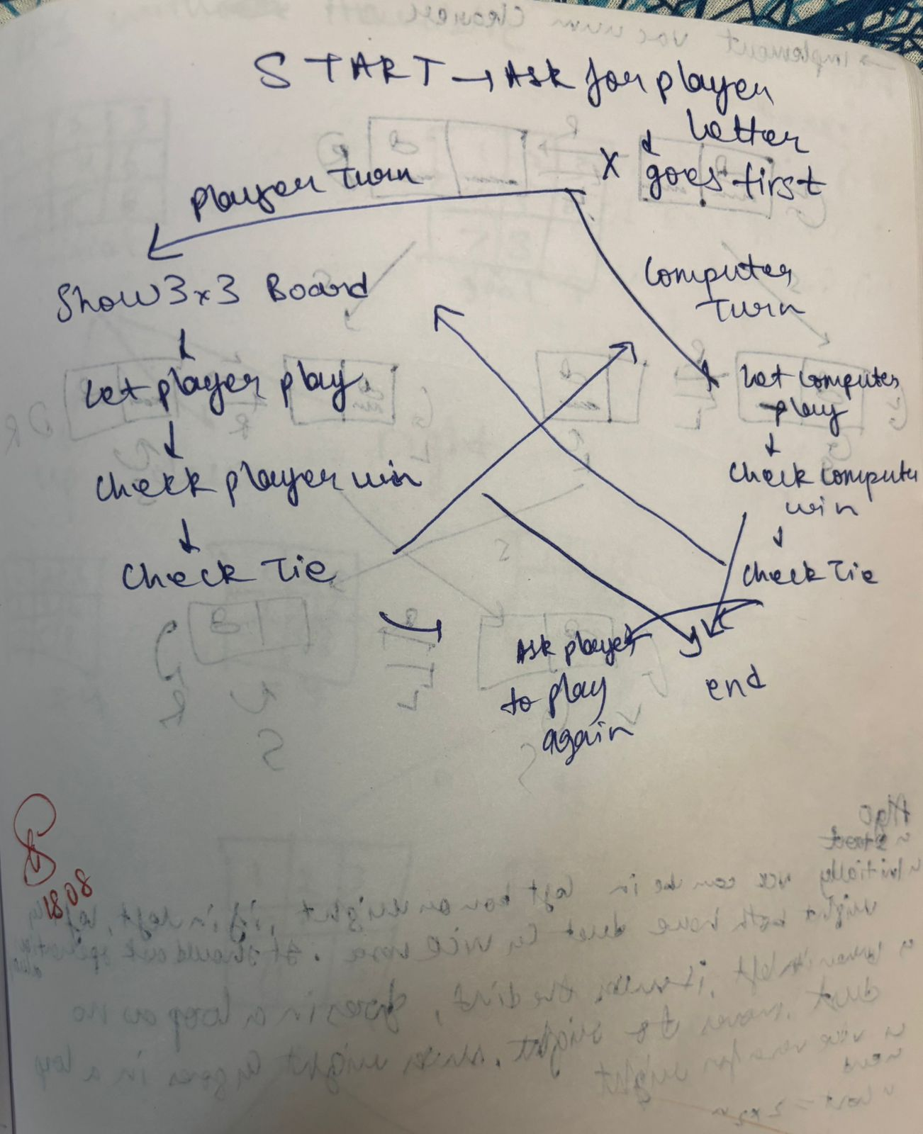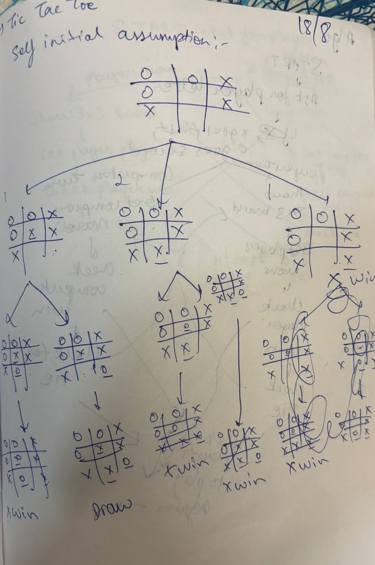

Code:

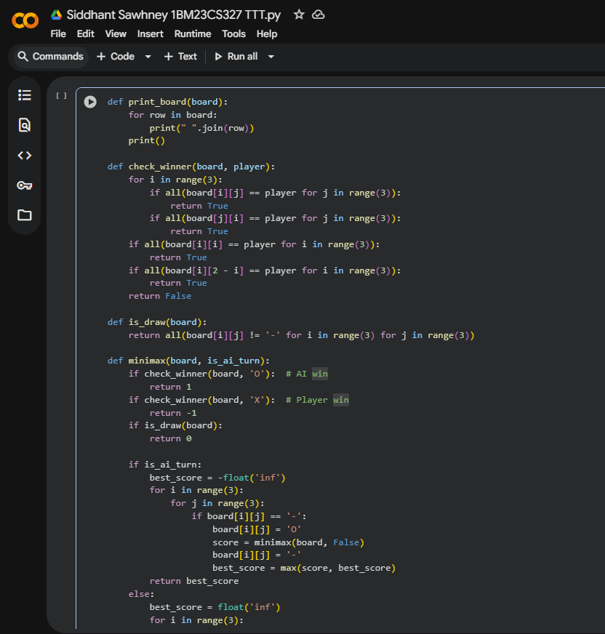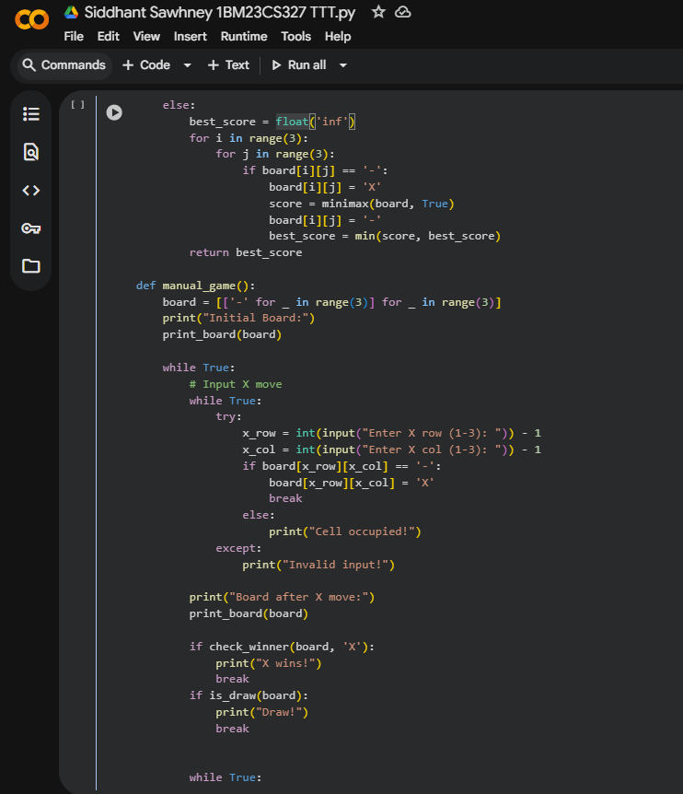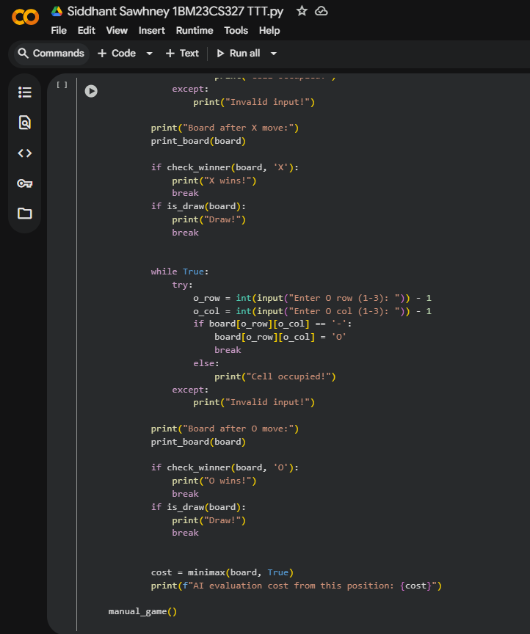

Output:

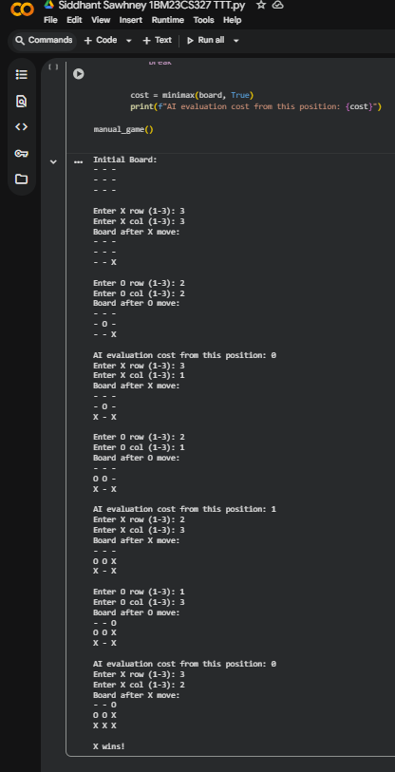

**Implement vacuum cleaner agent**

Algorithm:

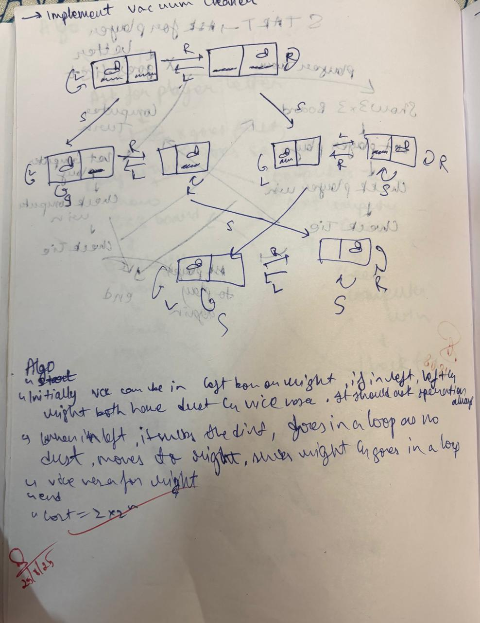

Code:

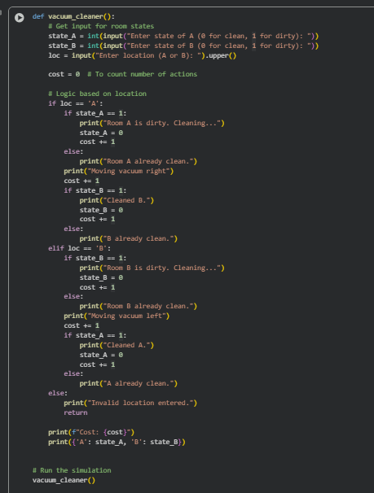

Output:

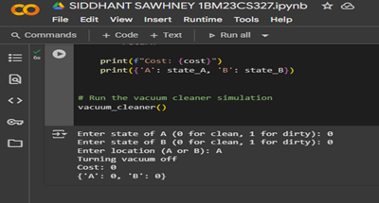 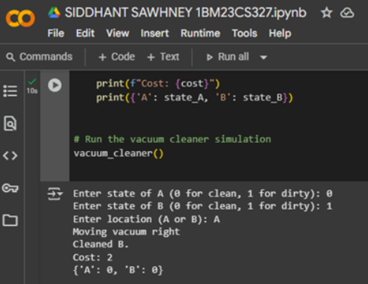

**2. BFS wirh Heuristic**

Algorithm:

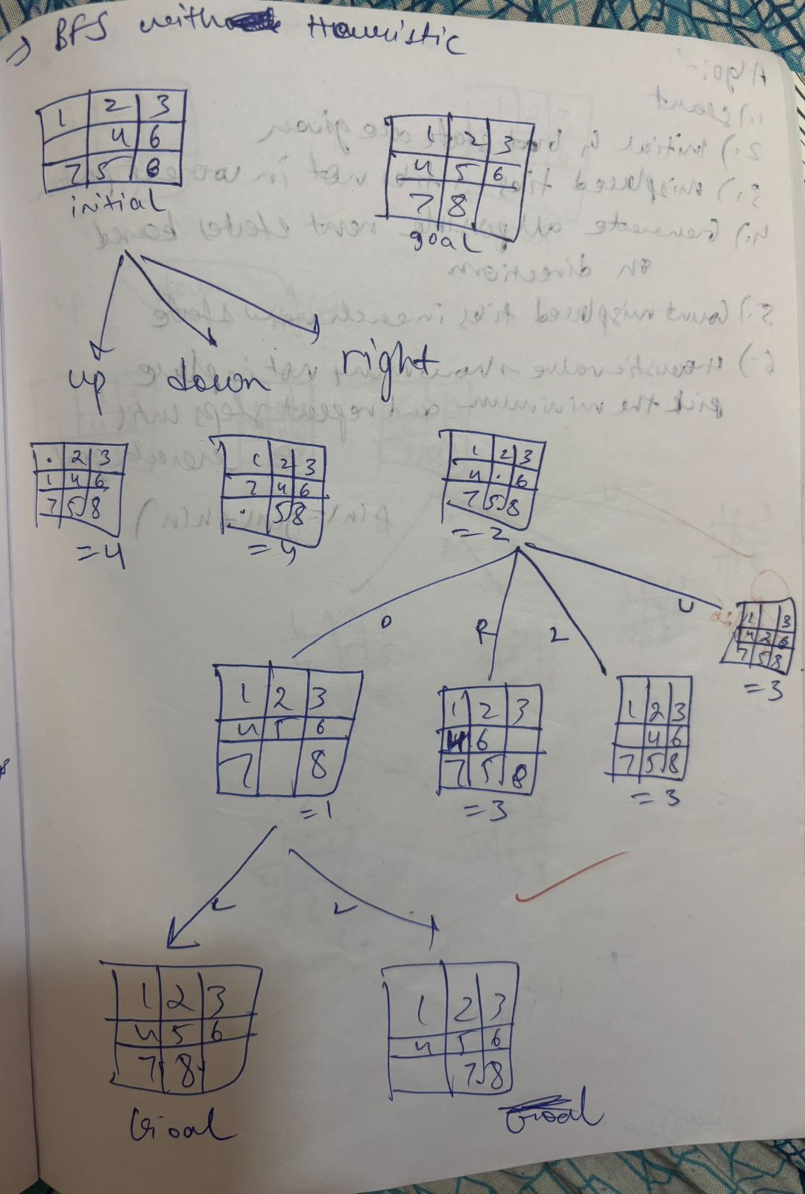

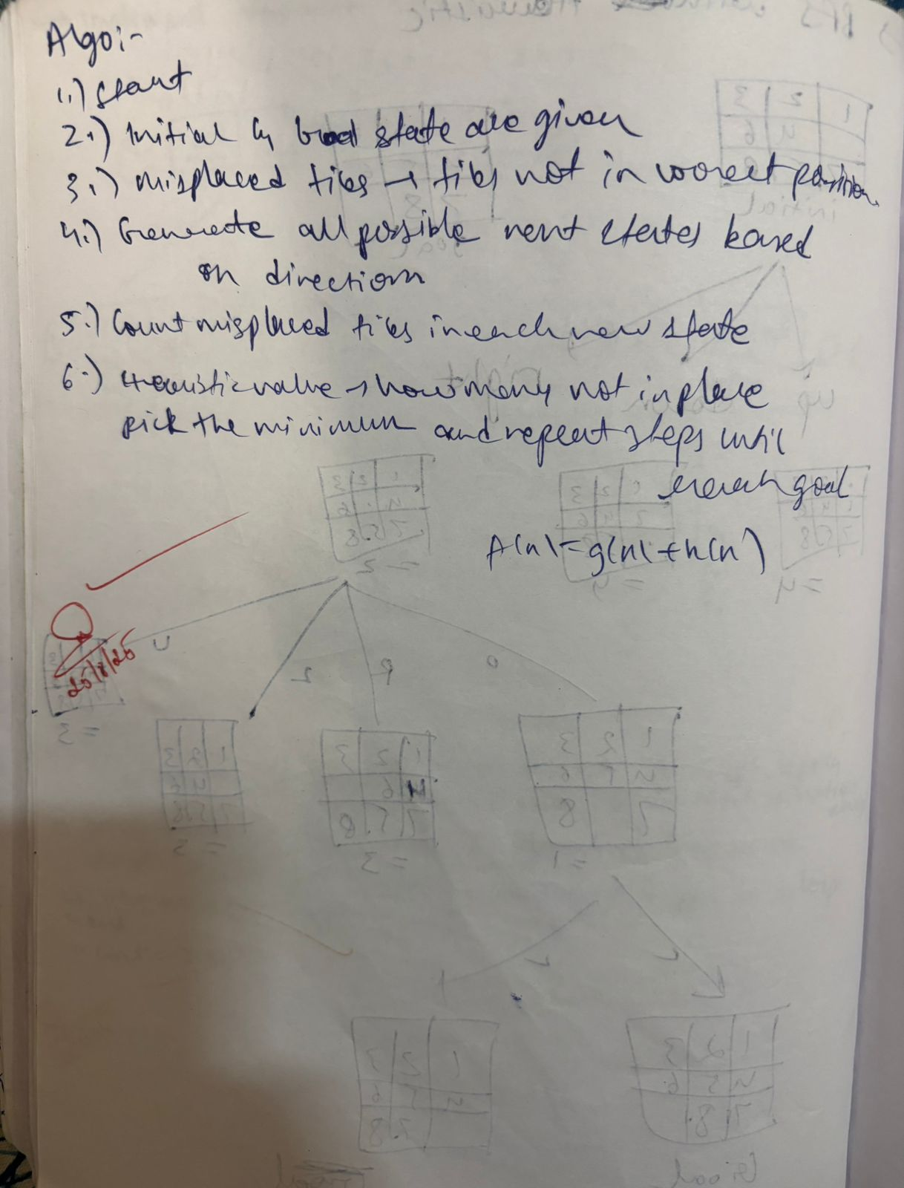

Code:

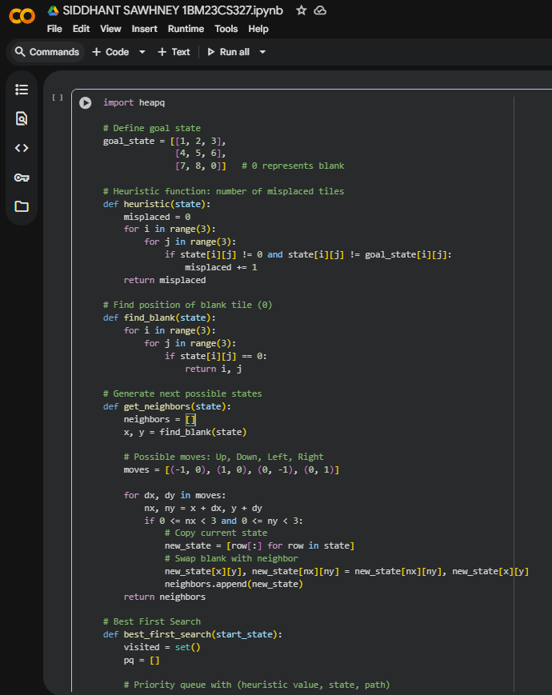 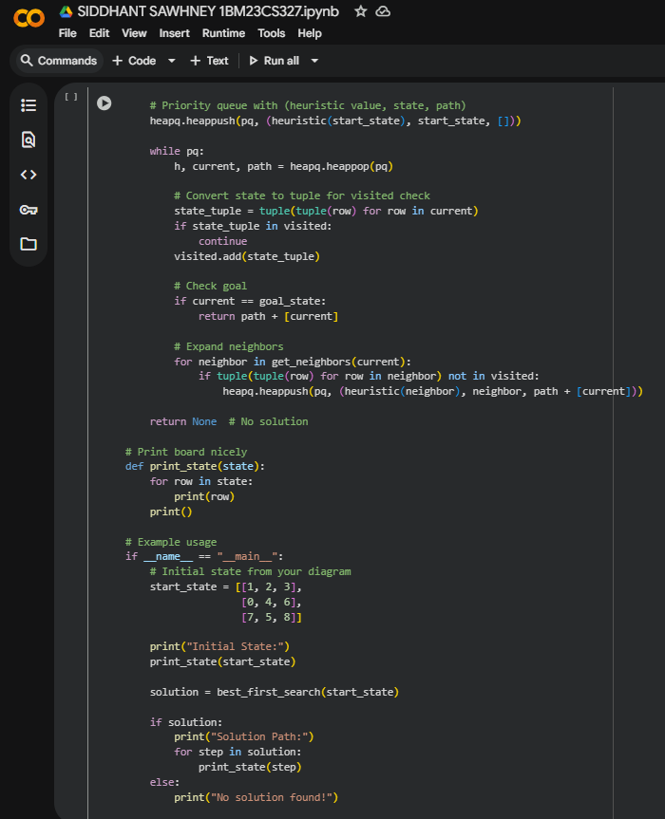

Output:

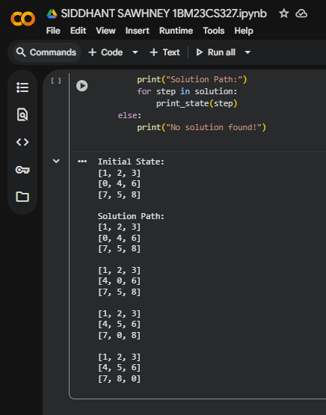

**BFS wirhout Heuristic**

Algorithm:

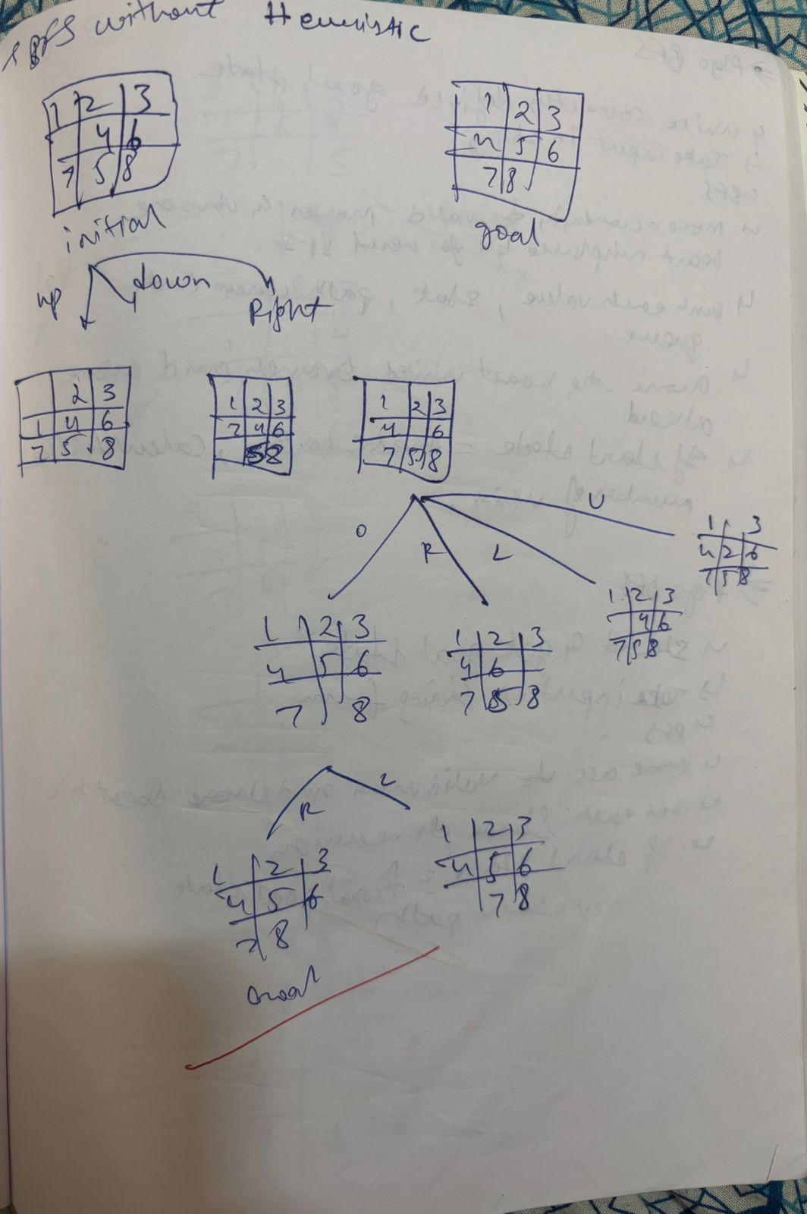

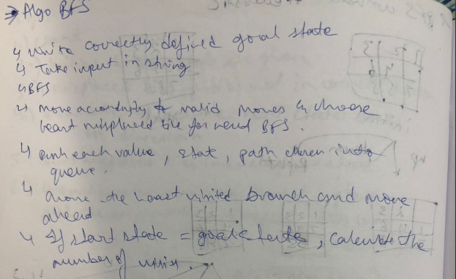

Code:

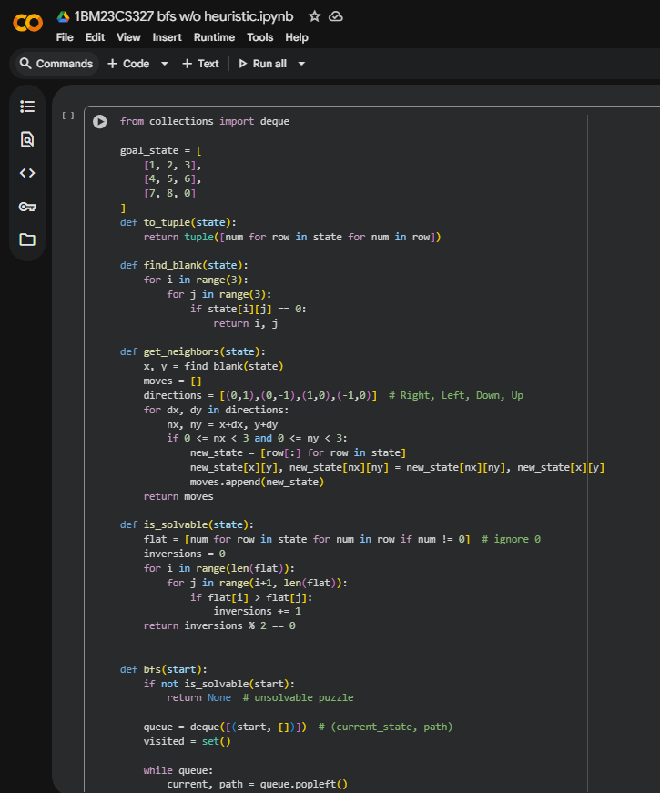 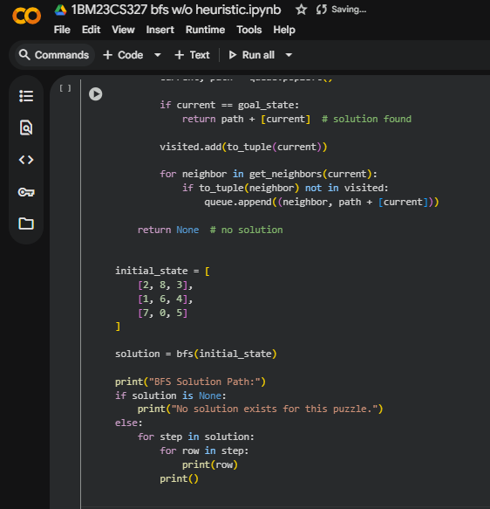

Output:



**DFS**

Algorithm:

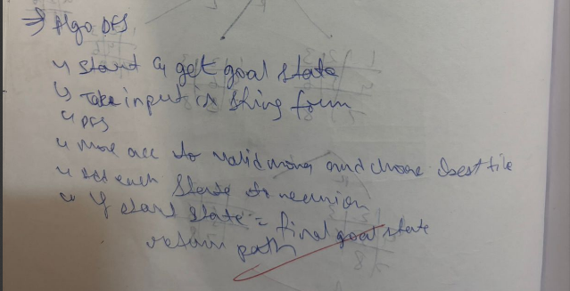

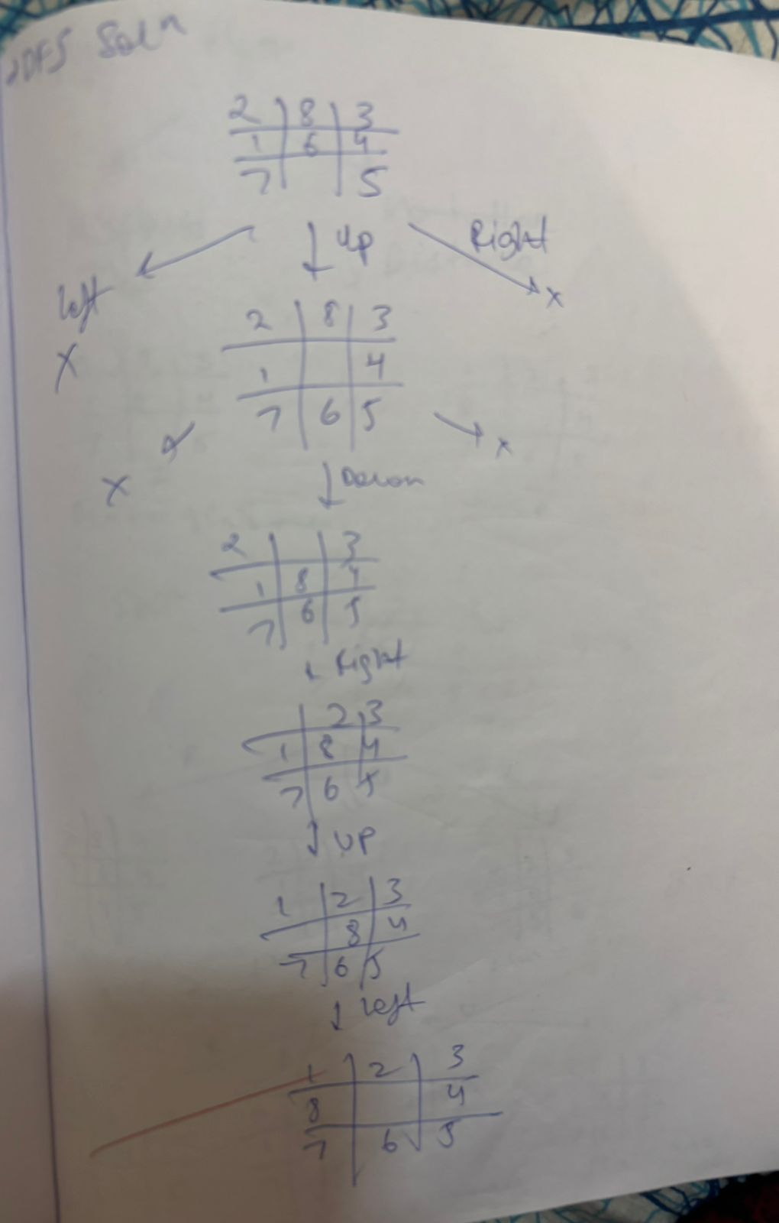

**3. Implement A* search algorithm**

Algorithm:

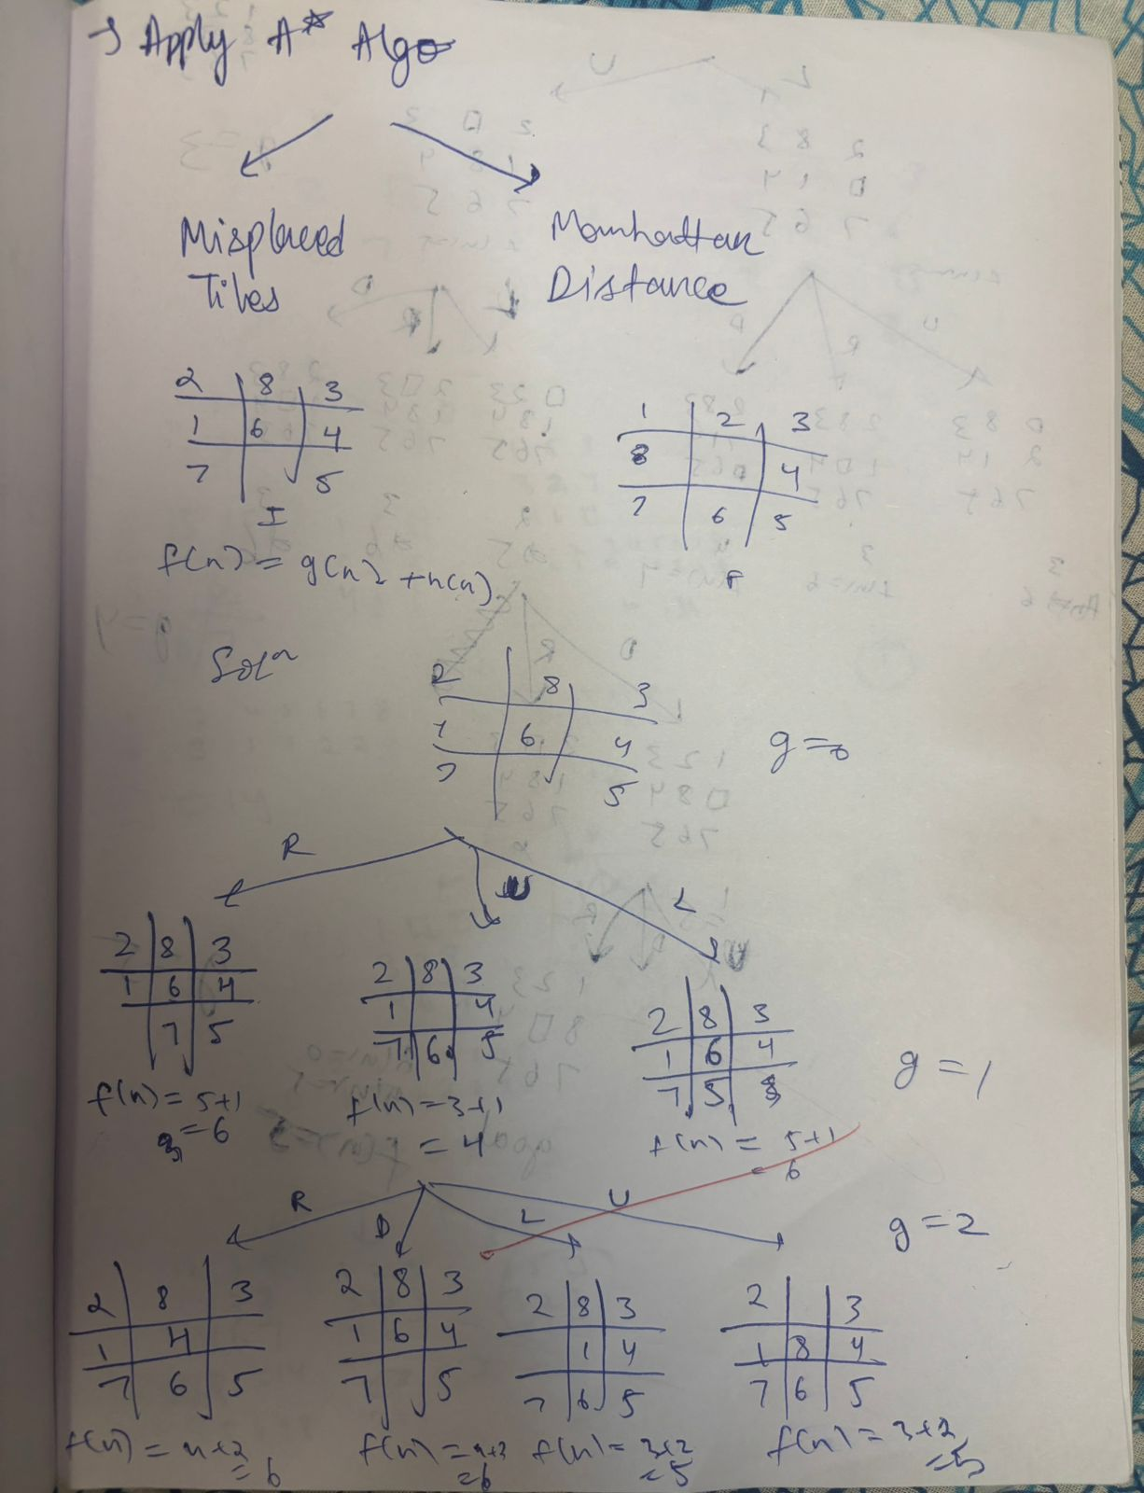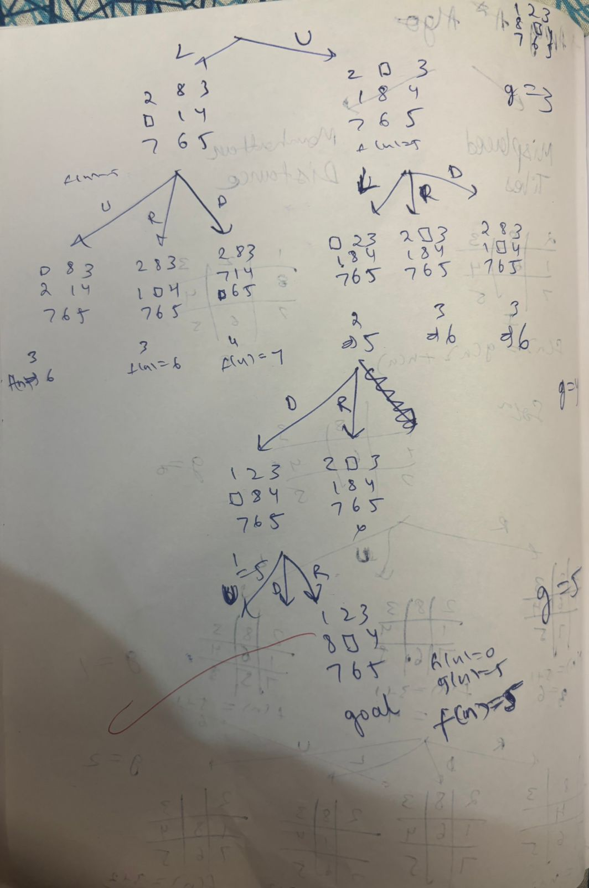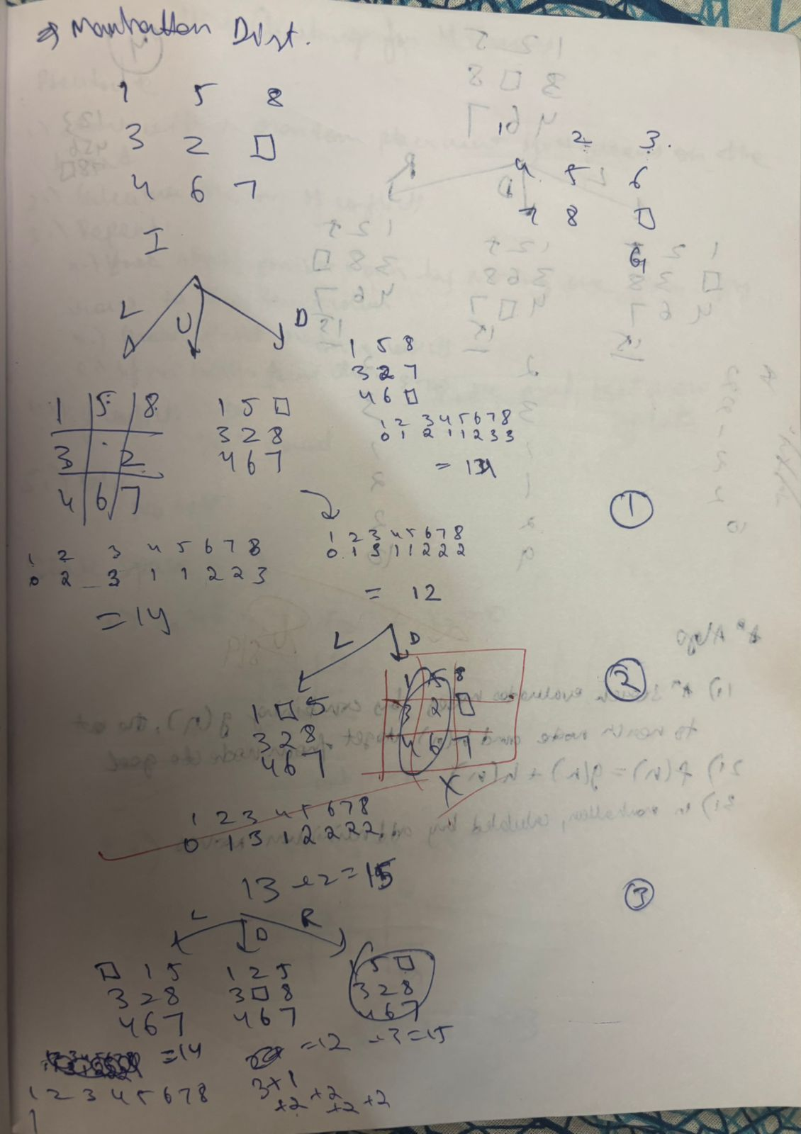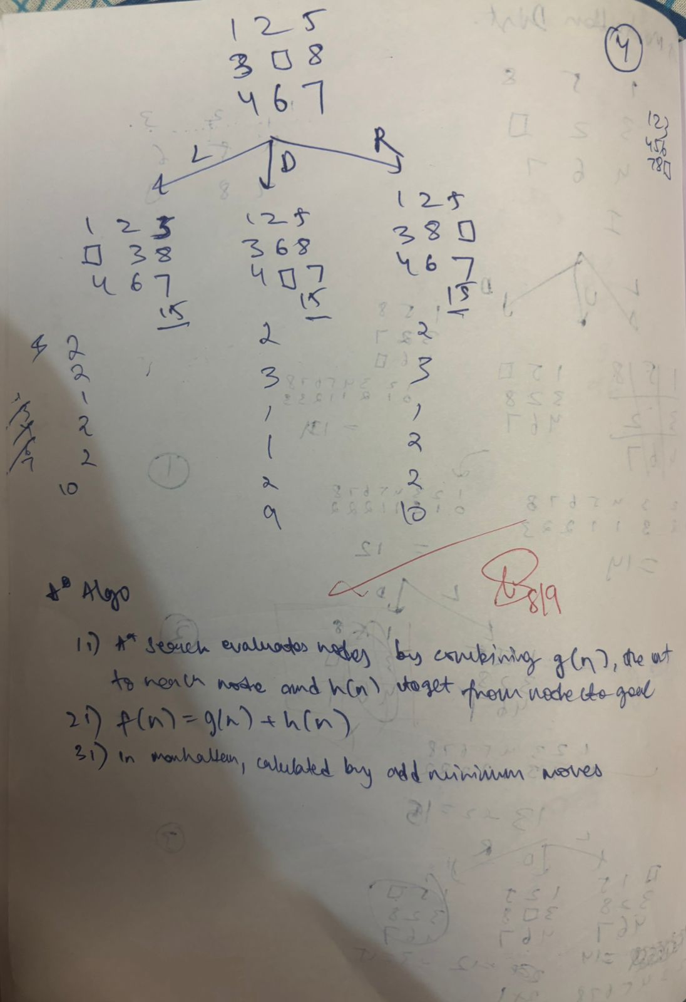

Code & Output:

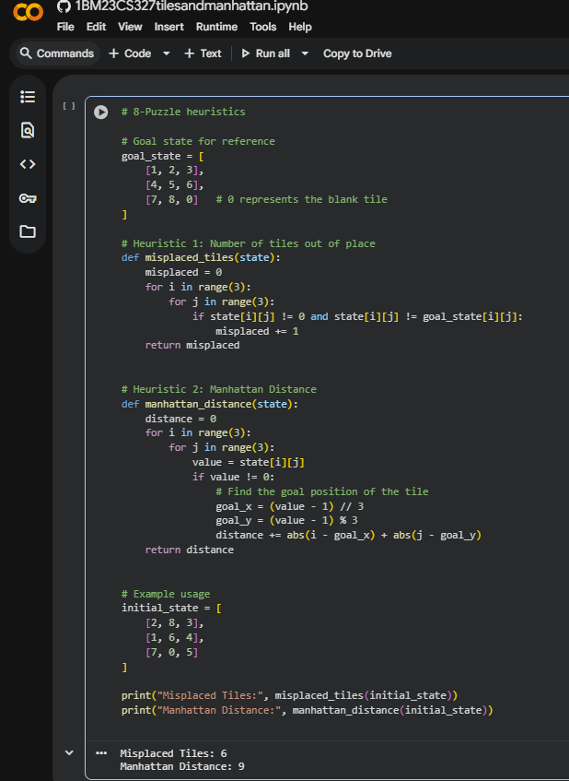

**4. Implement Hill Climbing search algorithm to solve N-Queens problem**

Algorithm:

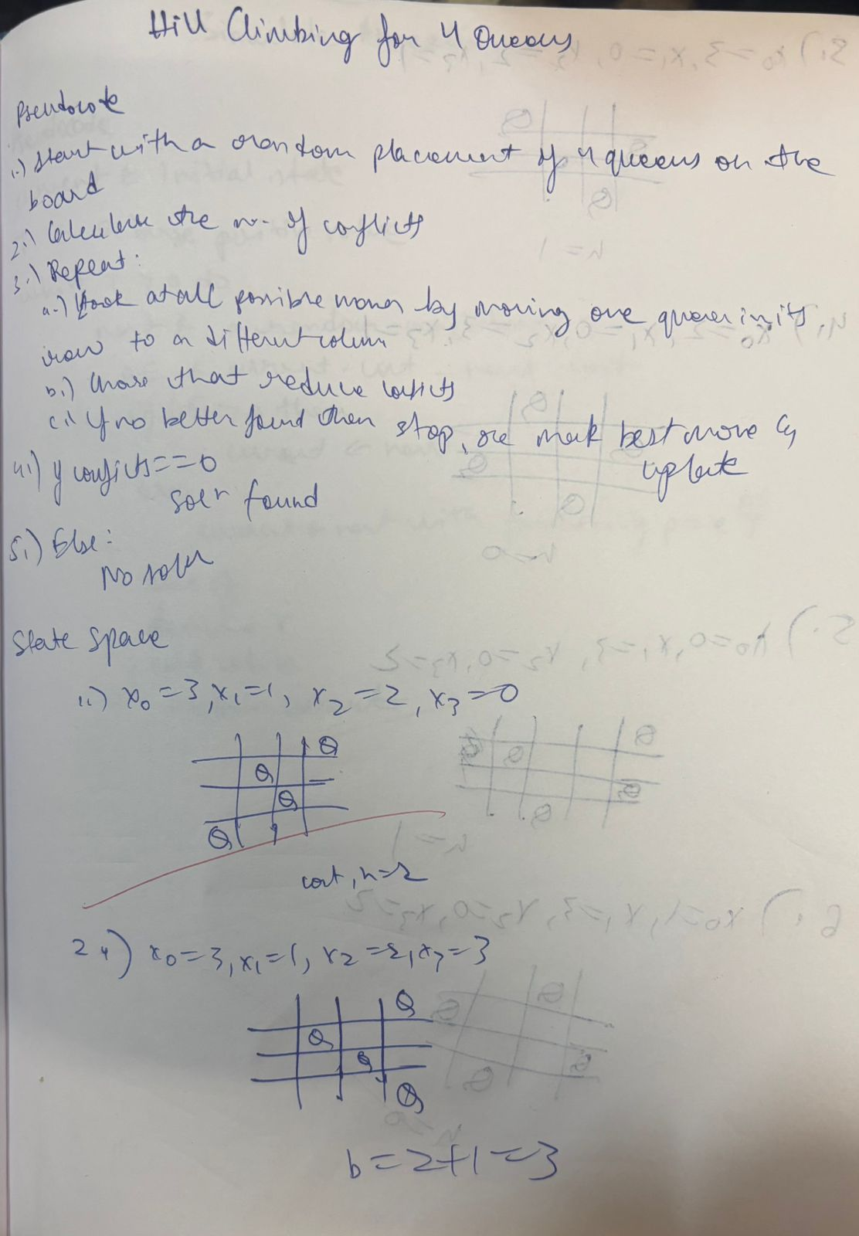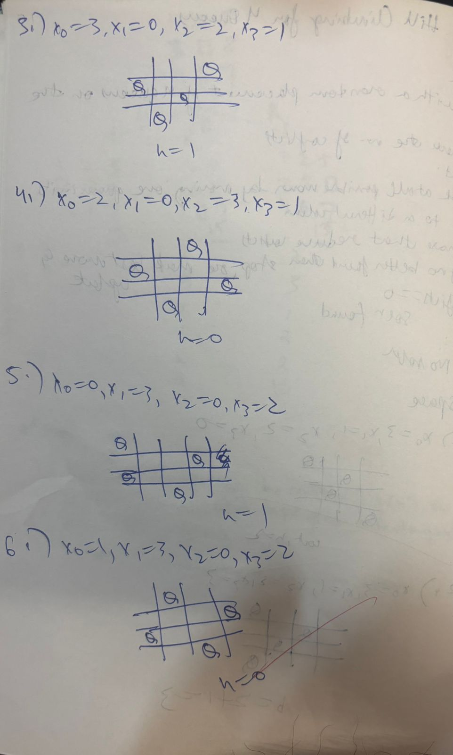

Code & Output:

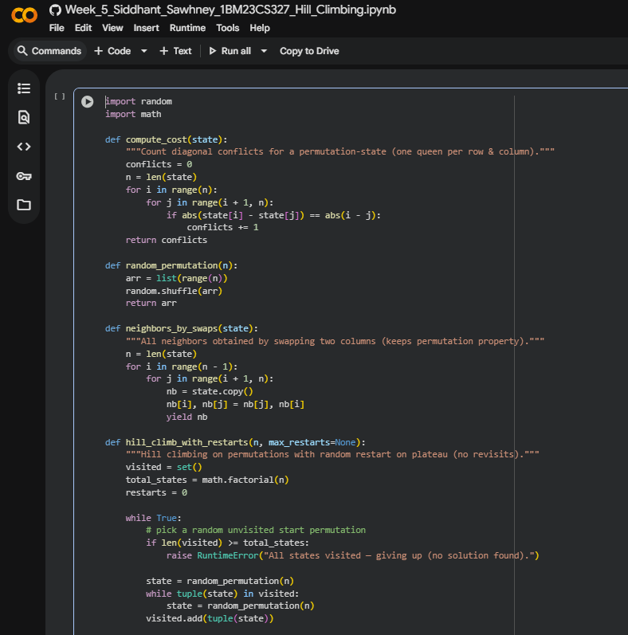

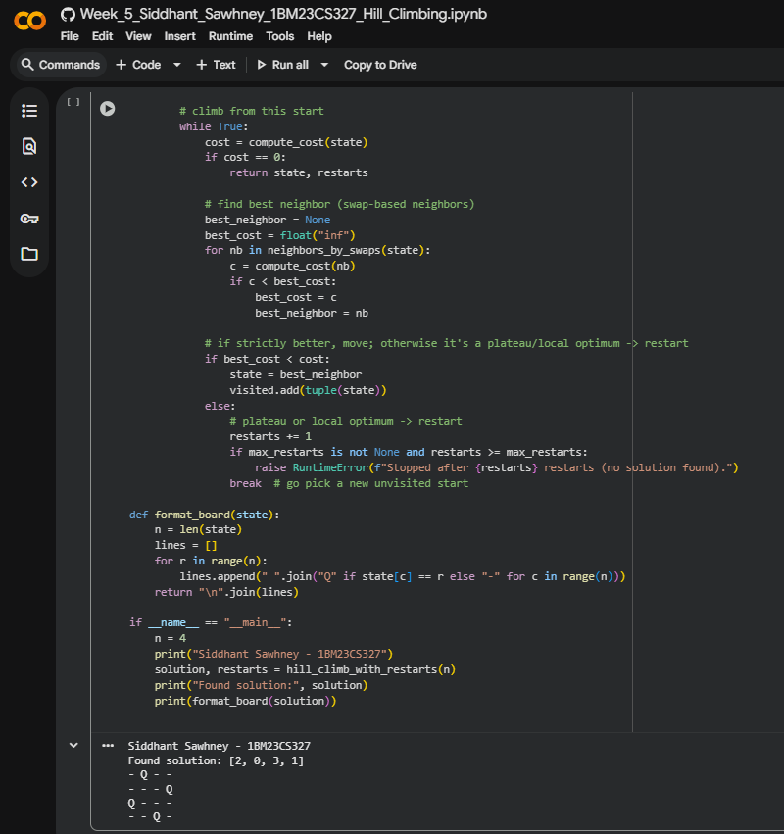

**5. Simulated Annealing to Solve 8-Queens problem**

Algorithm:

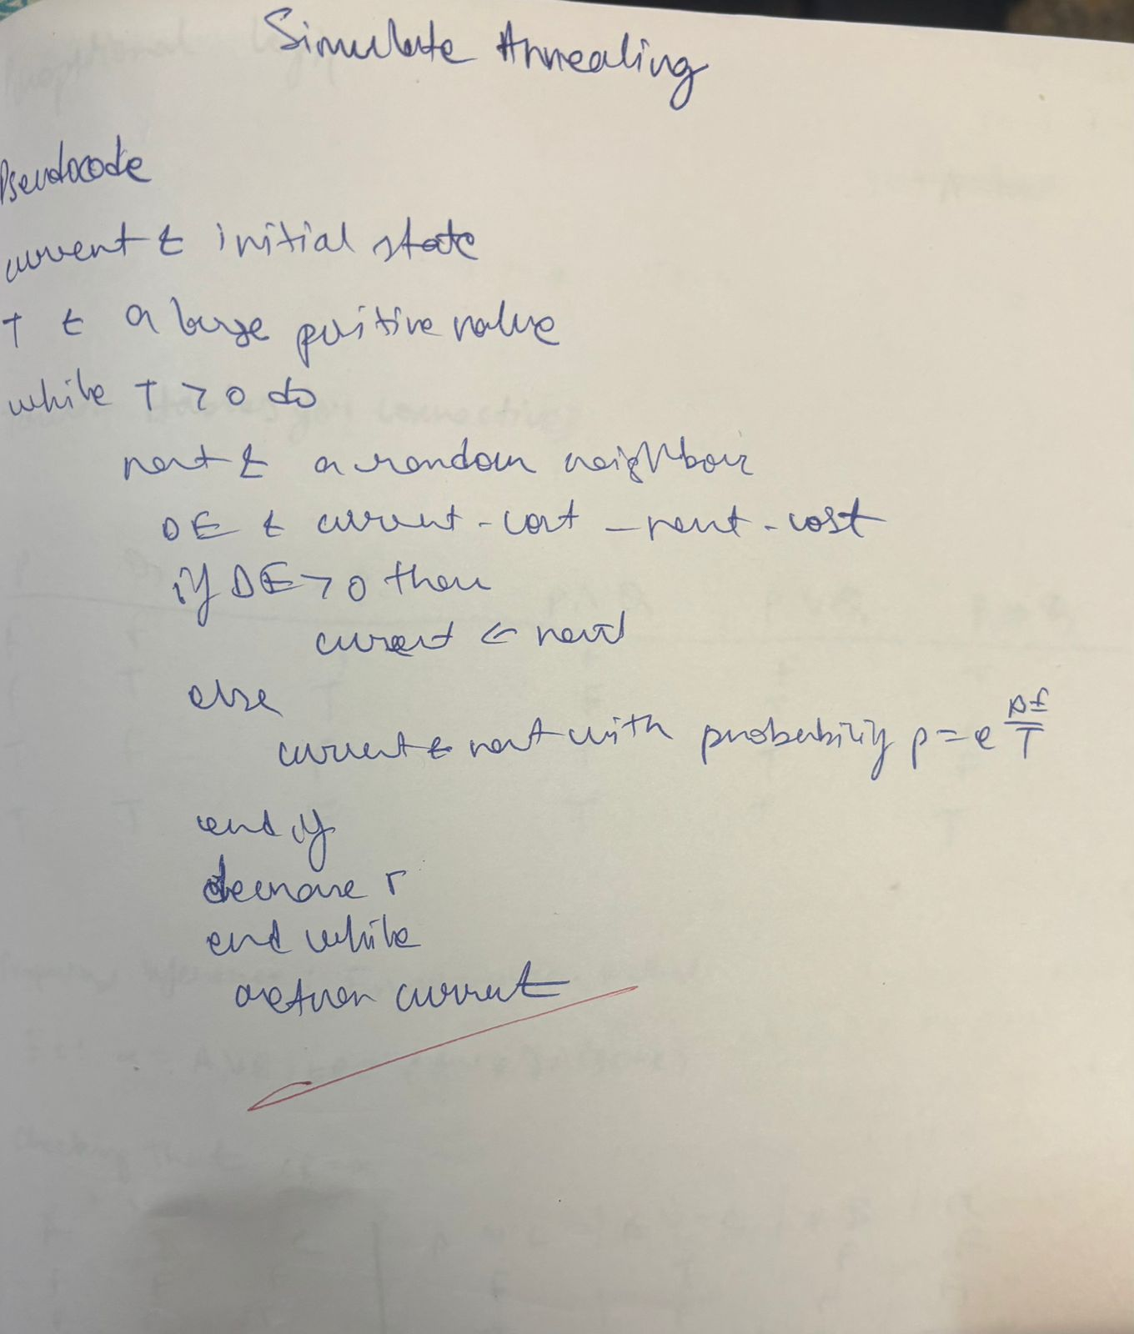

Code & Output:

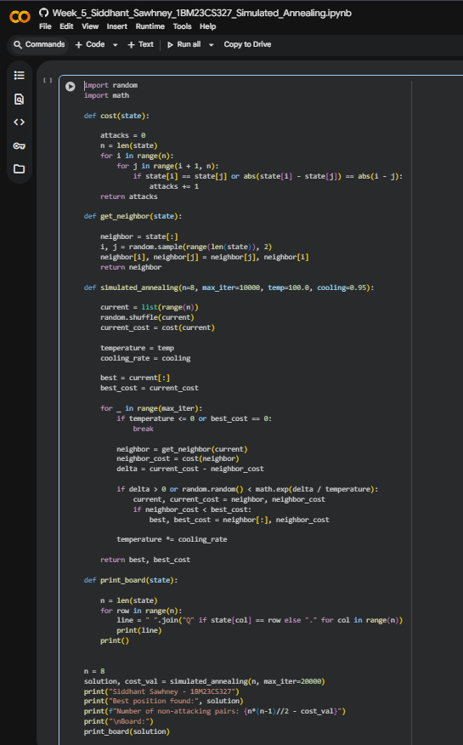

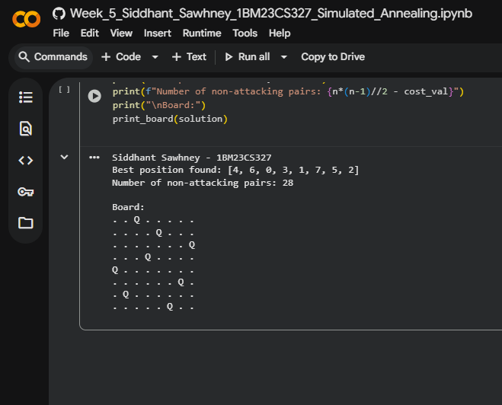

**6. Create a knowledge base using propositional logic and show that the given query entails the knowledge base or not.**

Algorithm:

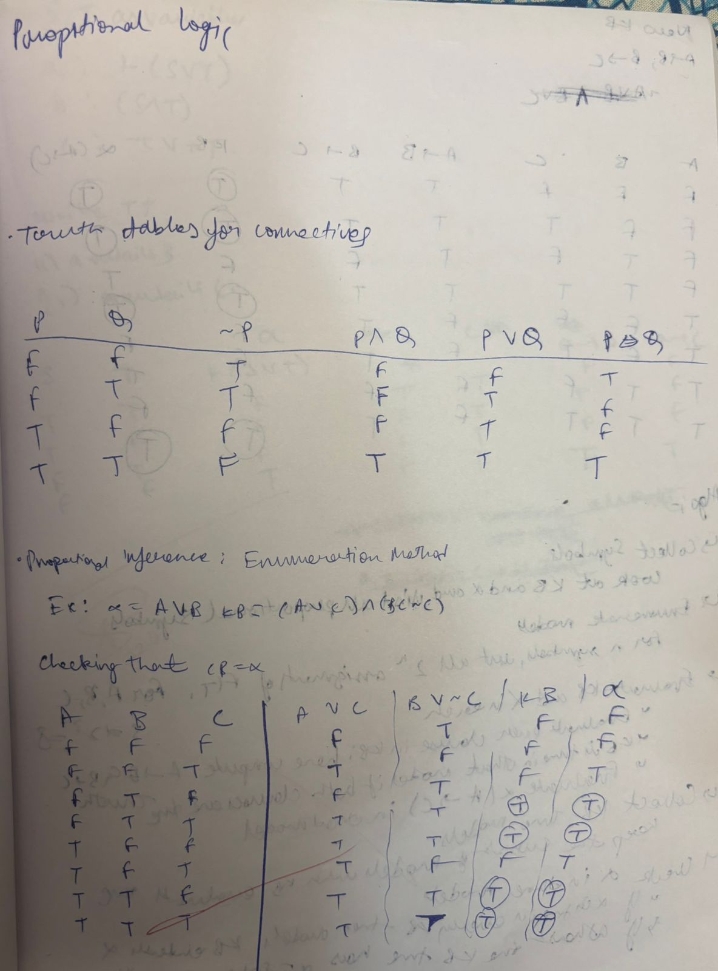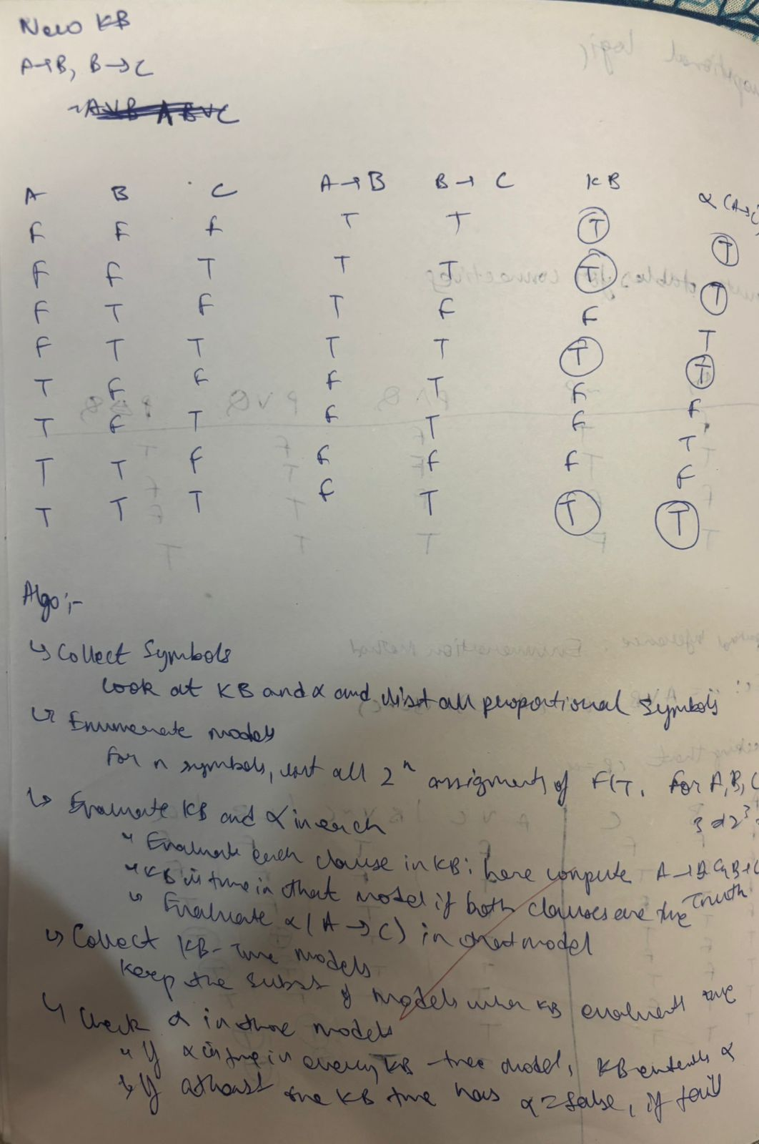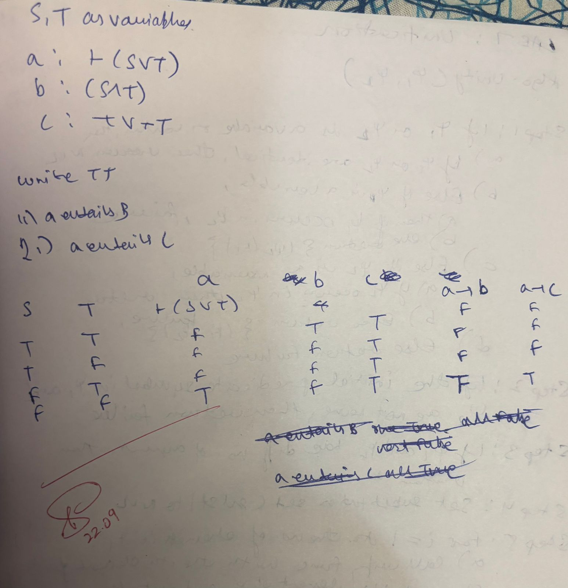

Code & Output:

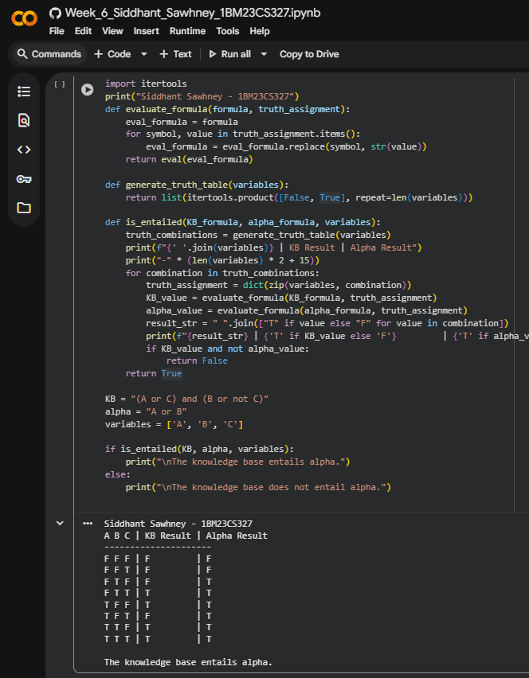

**7. Implement unification in first order logic**

Algorithm:

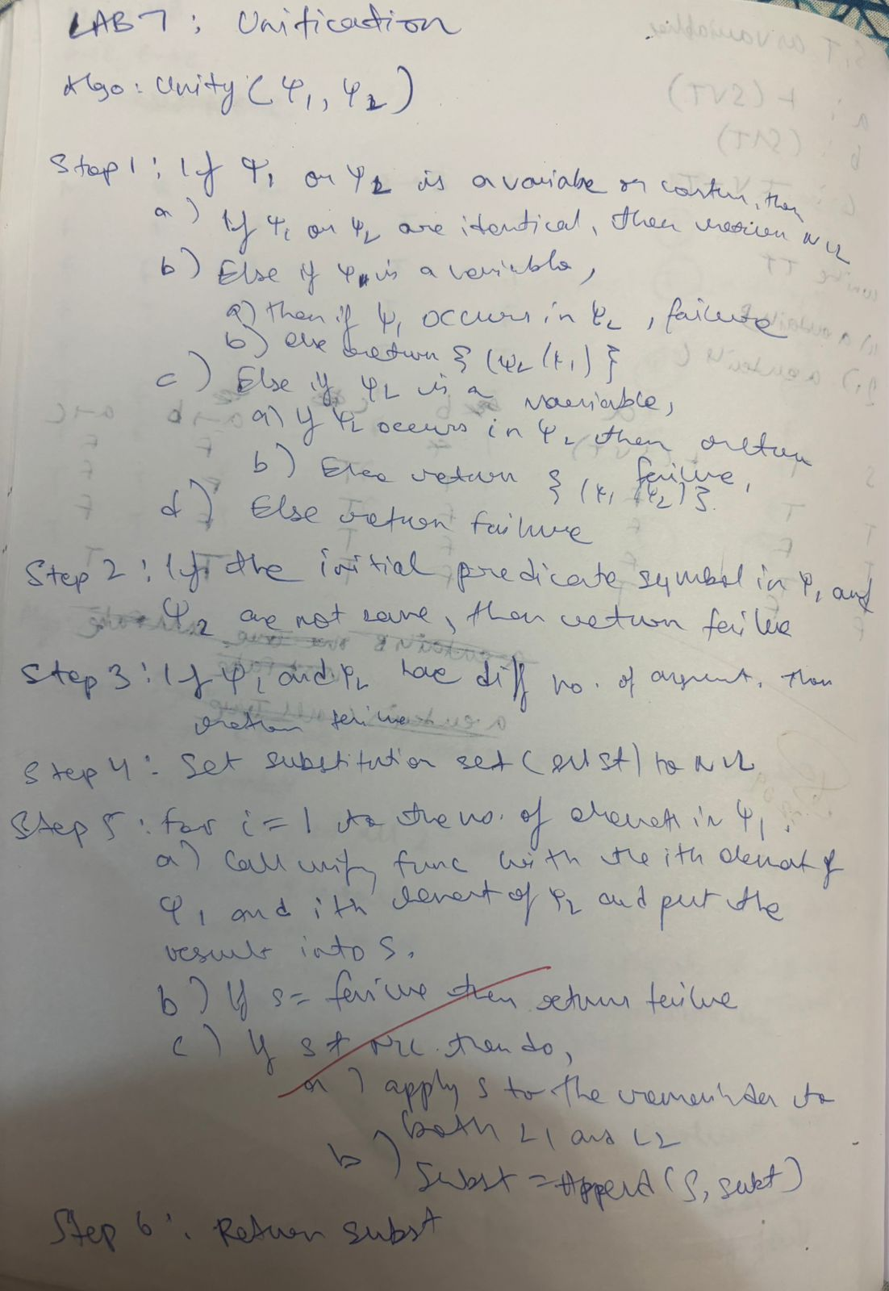

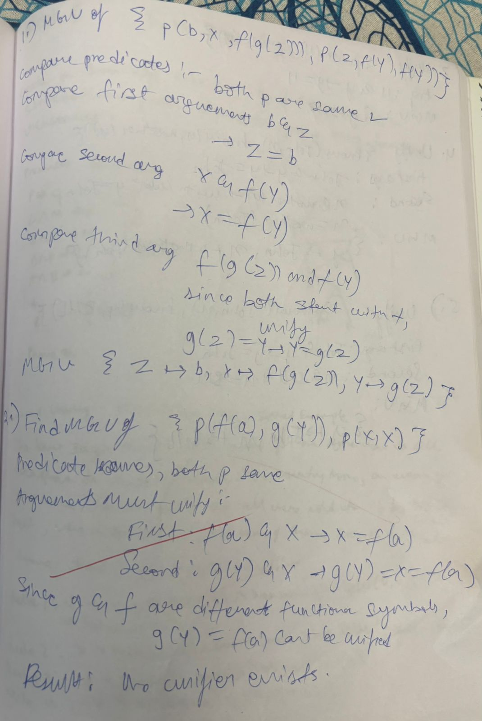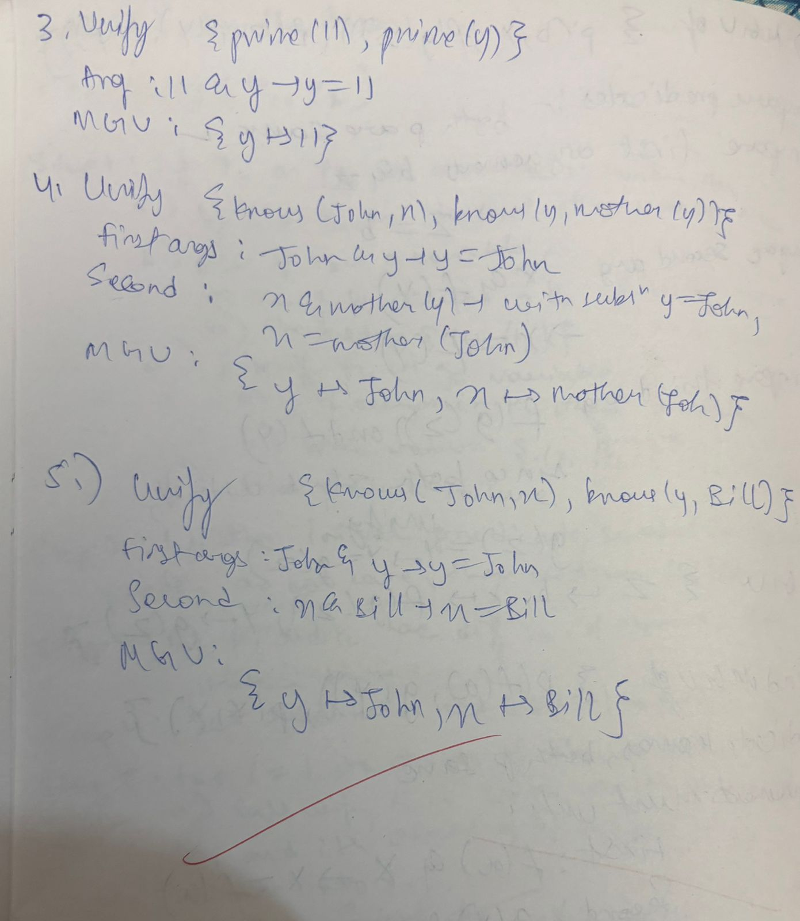

Code & Output:

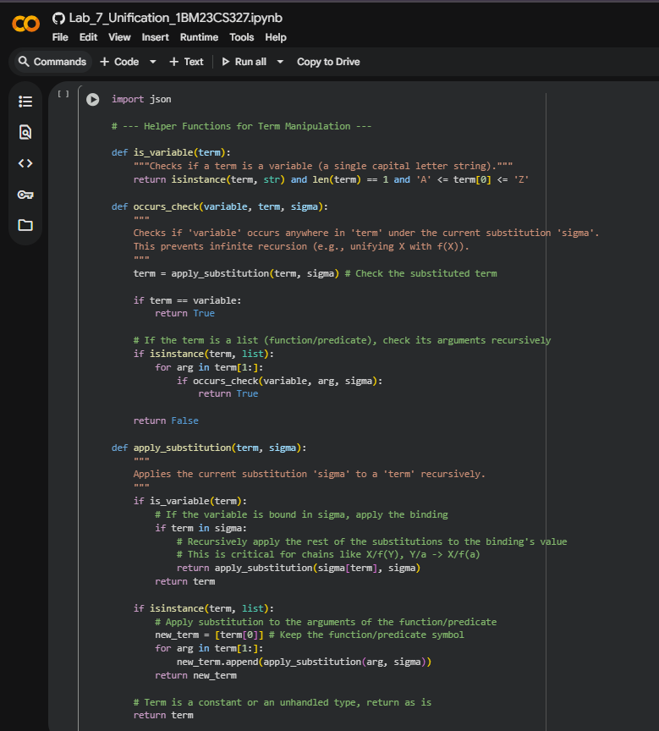

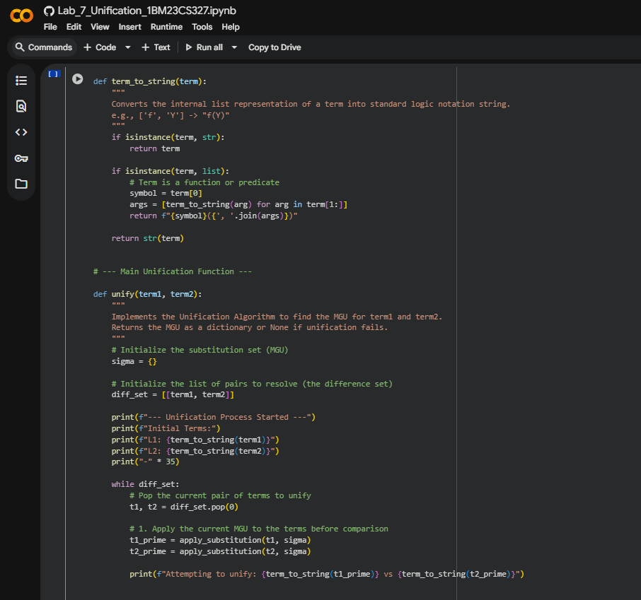 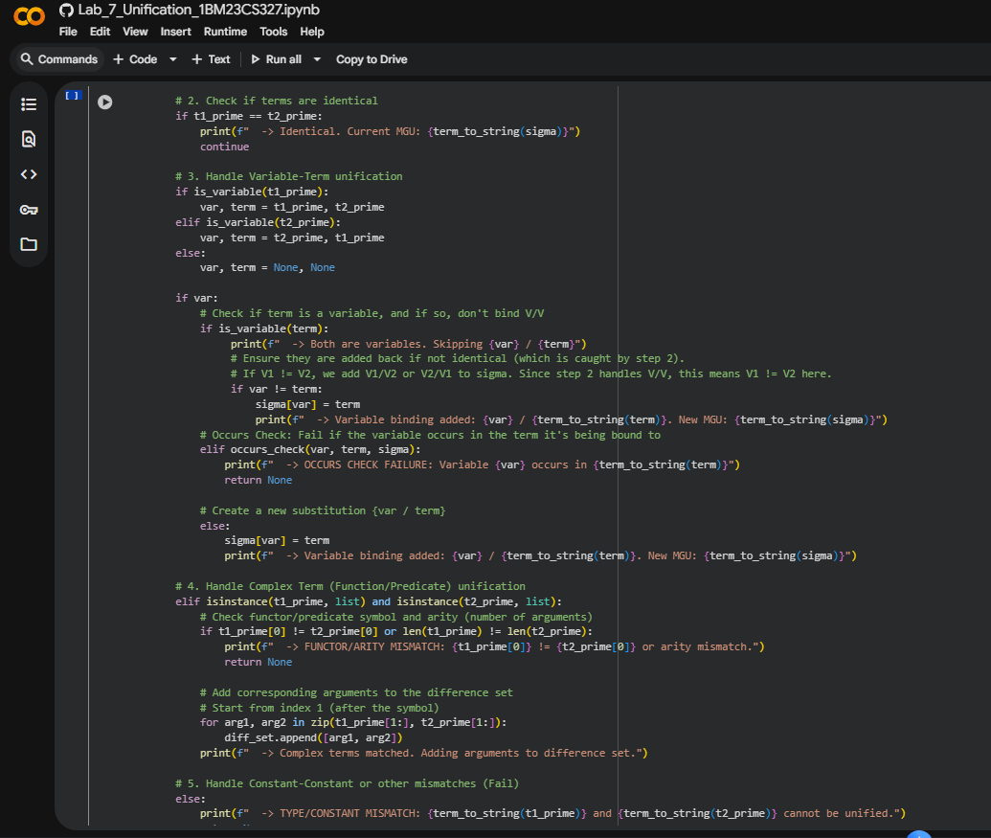 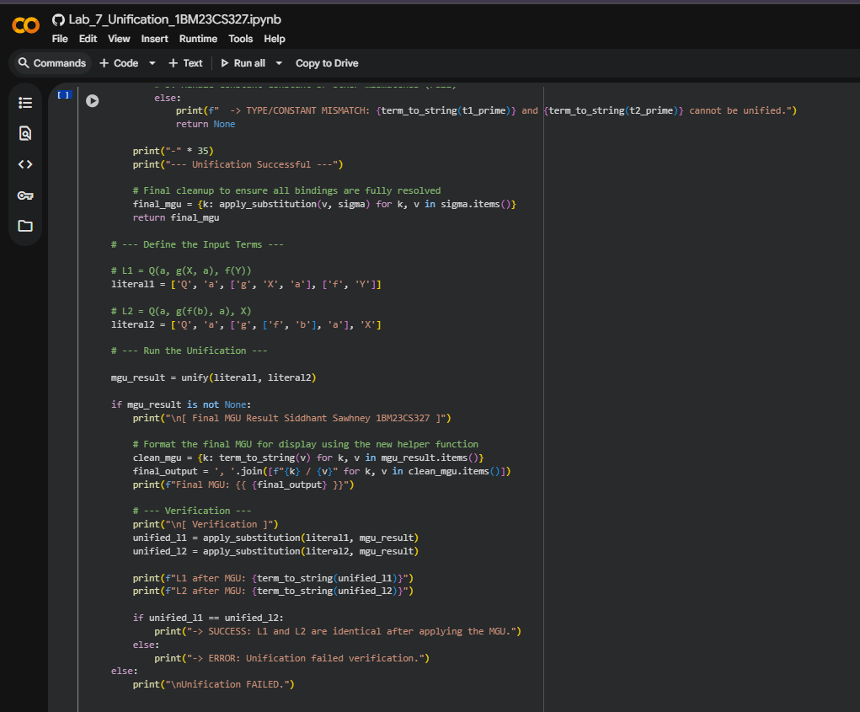

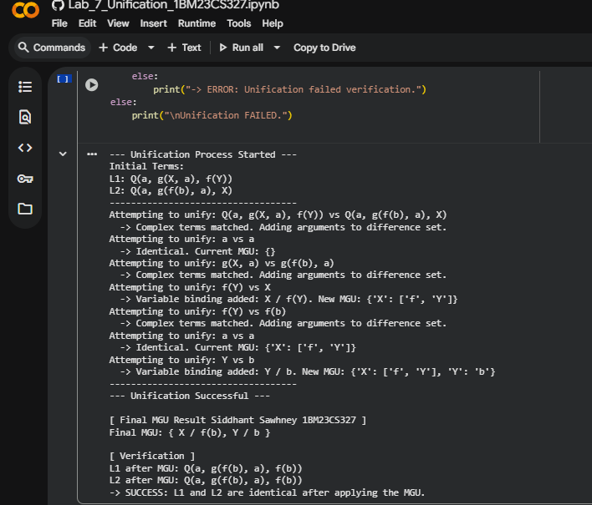

**8. Create a knowledge base consisting of first order logic statements and prove the given query using forward reasoning.**

Algorithm:

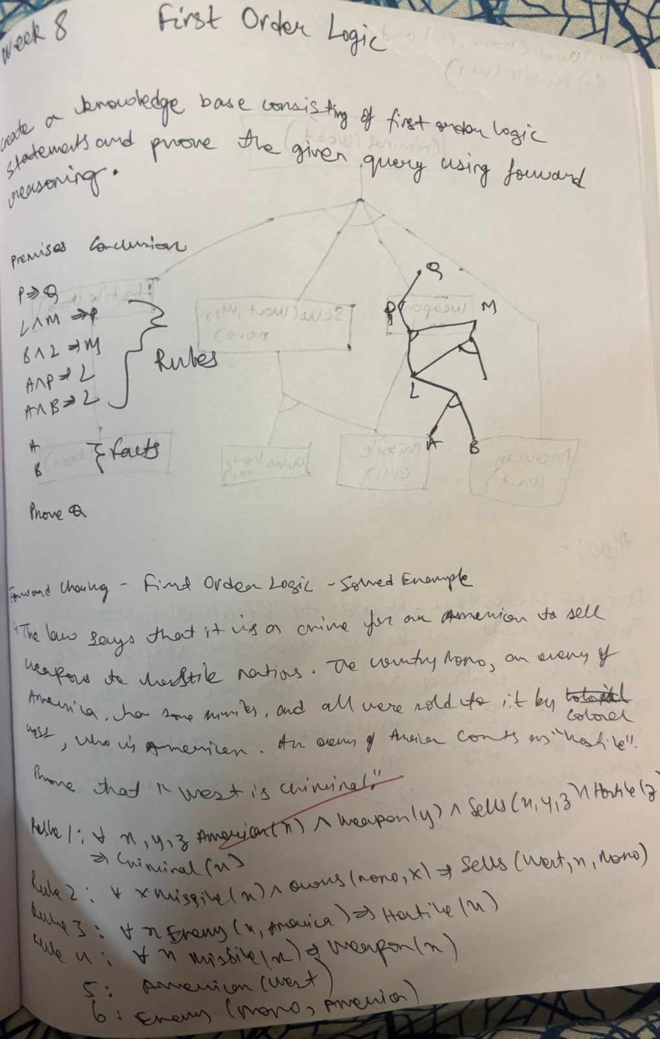

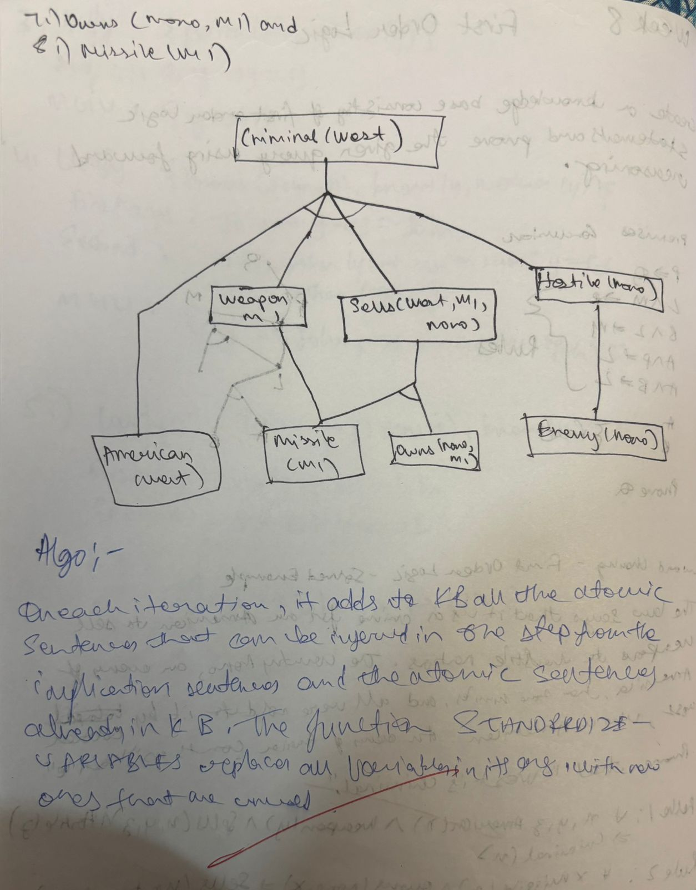

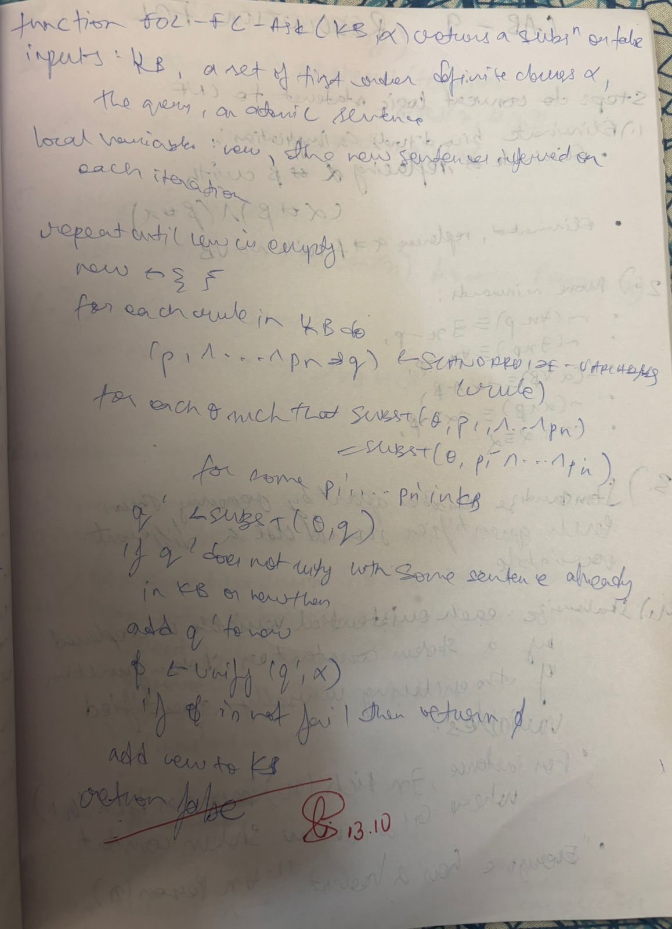

**9. Create a knowledge base consisting of first order logic statements and prove the given query using Resolution**

Algorithm:

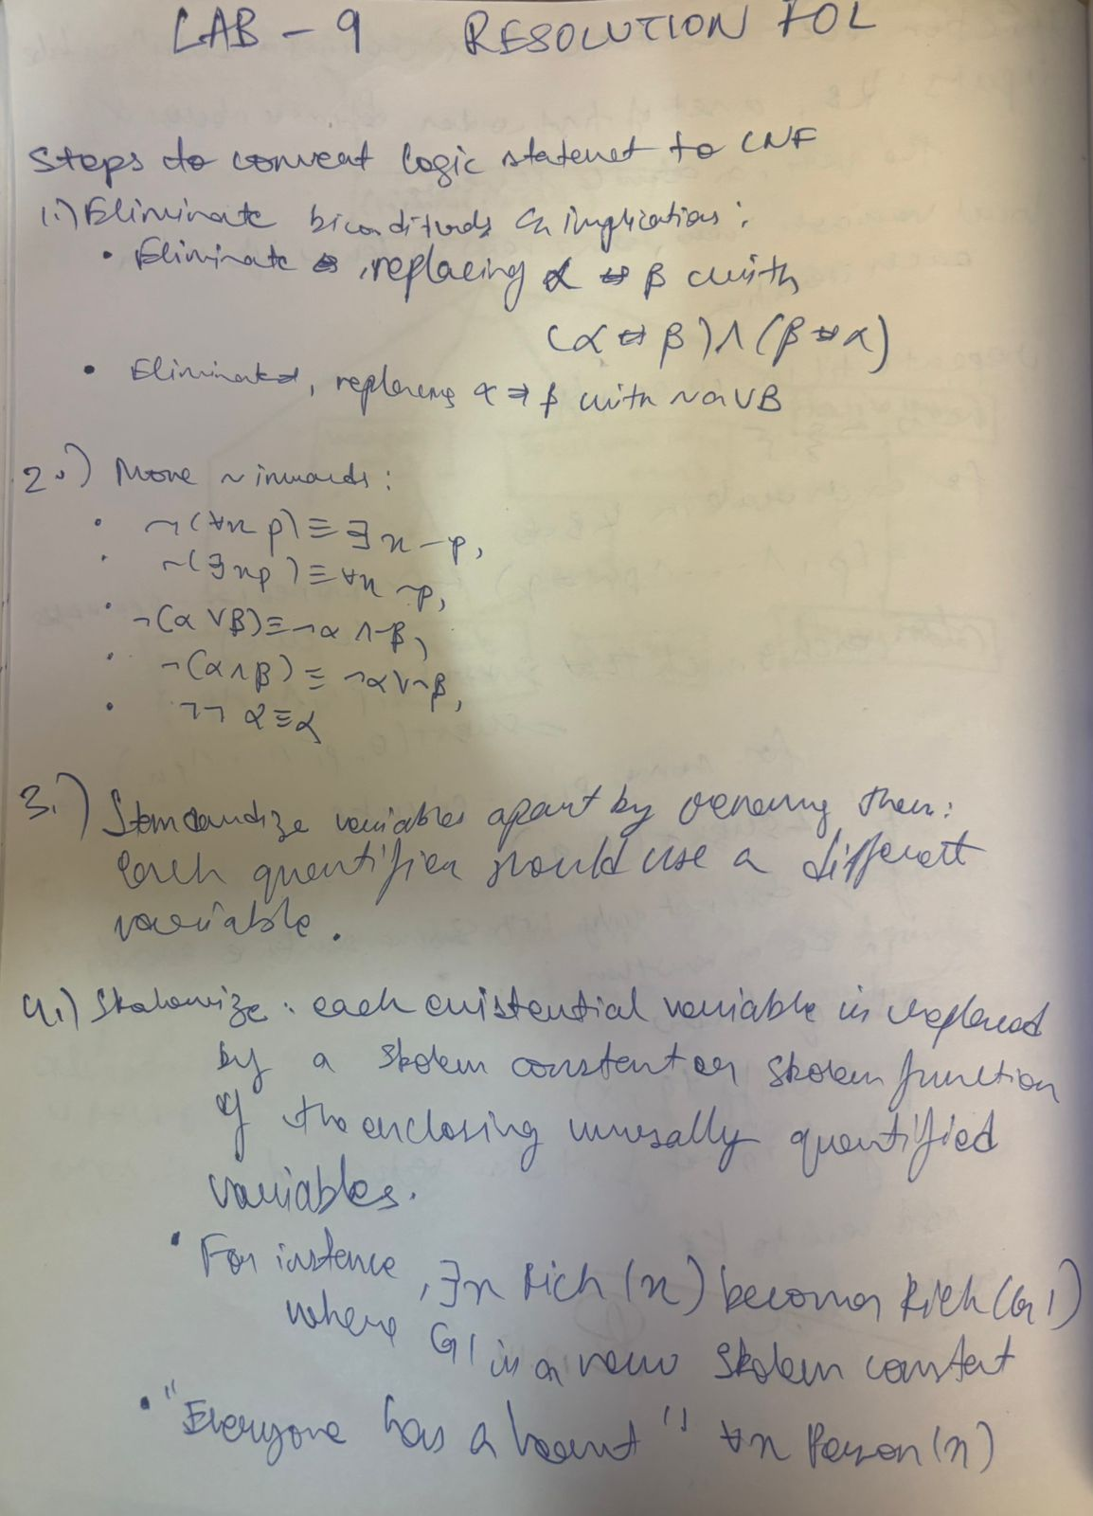

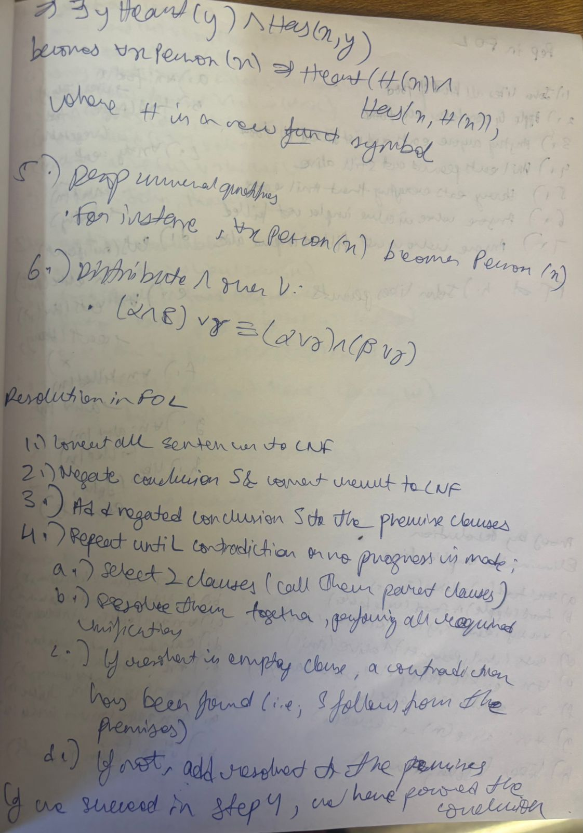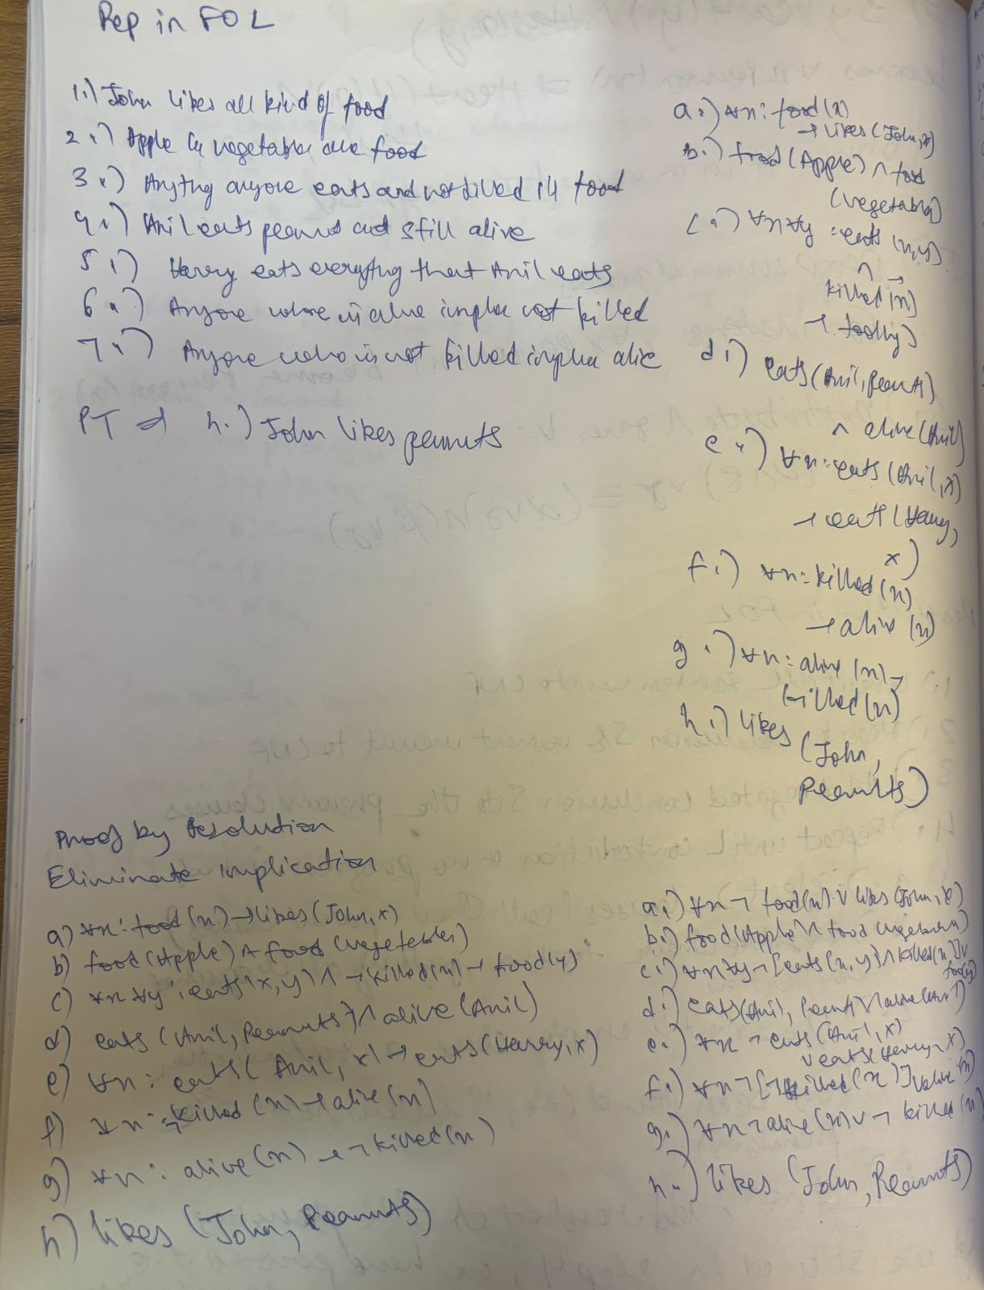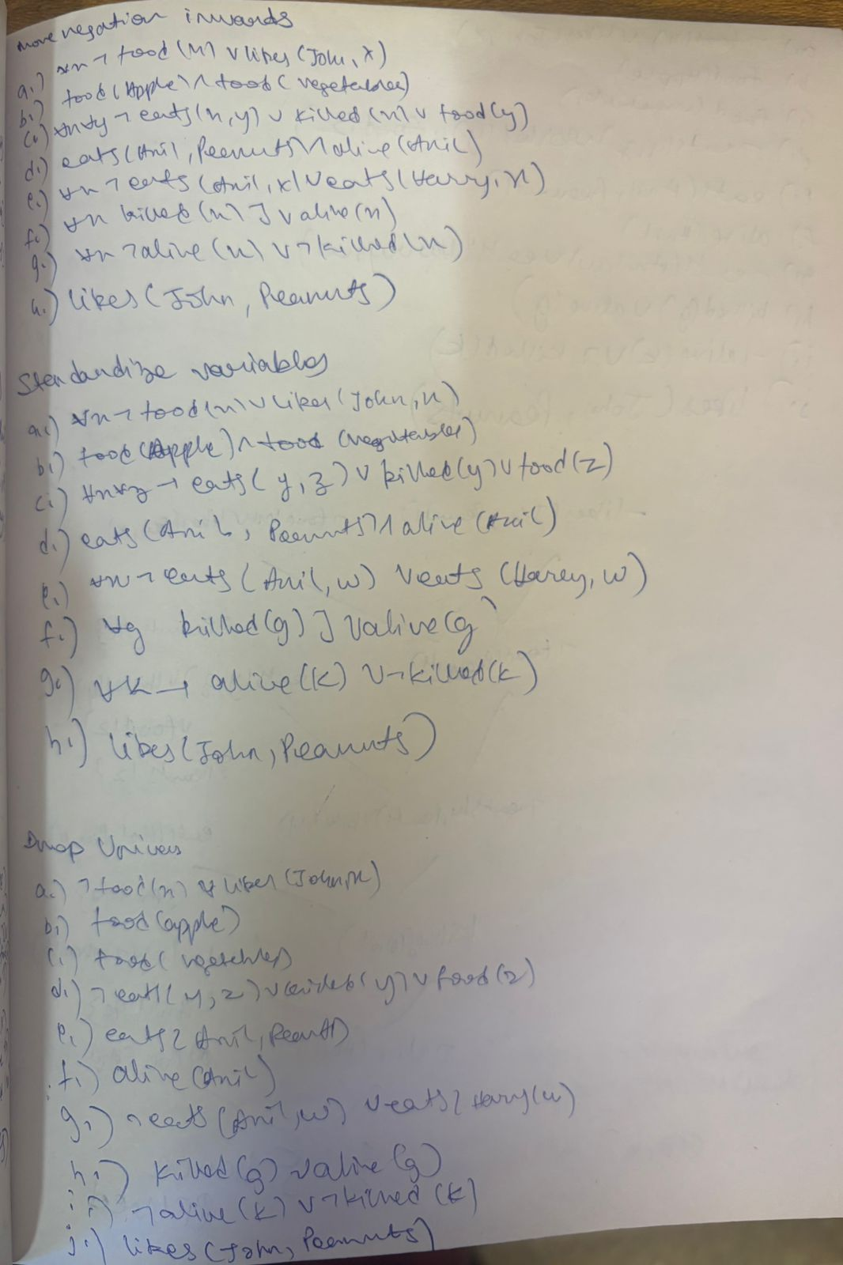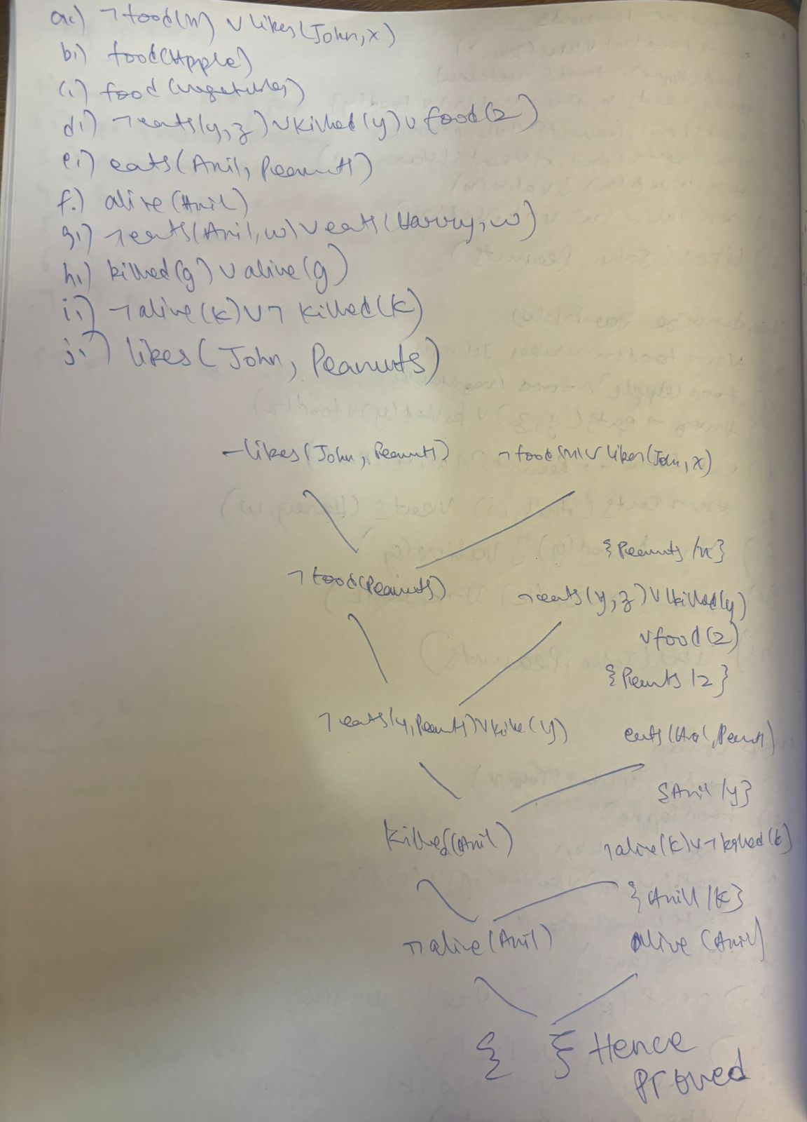

Code & Output:

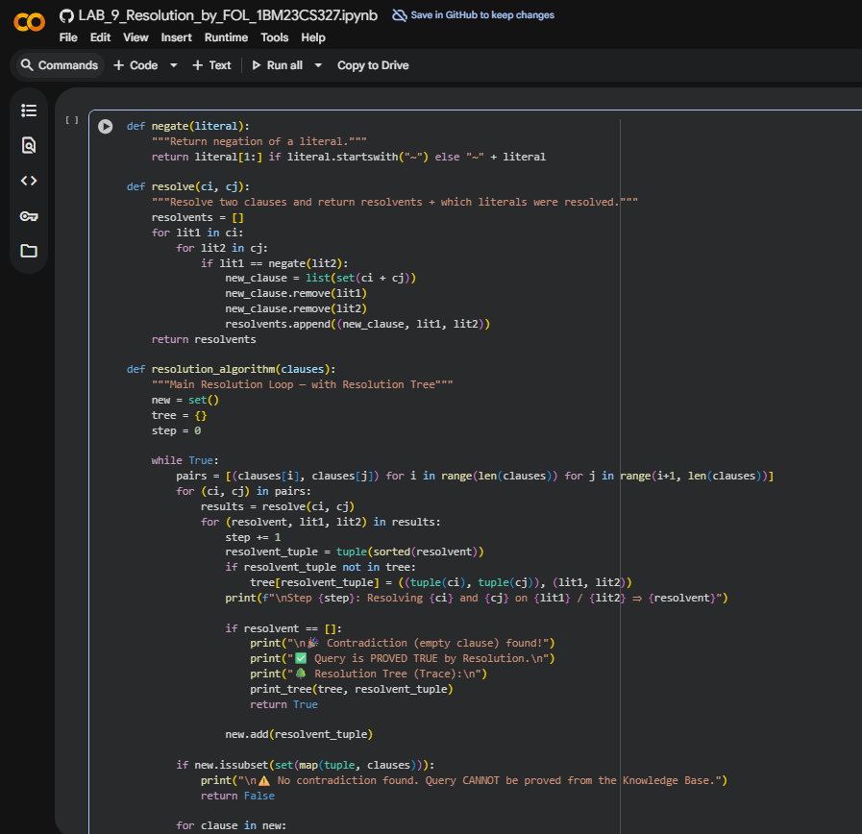 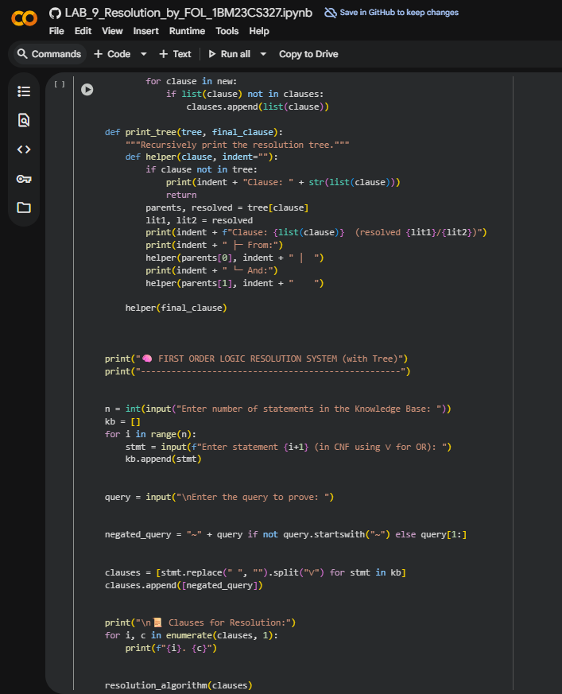 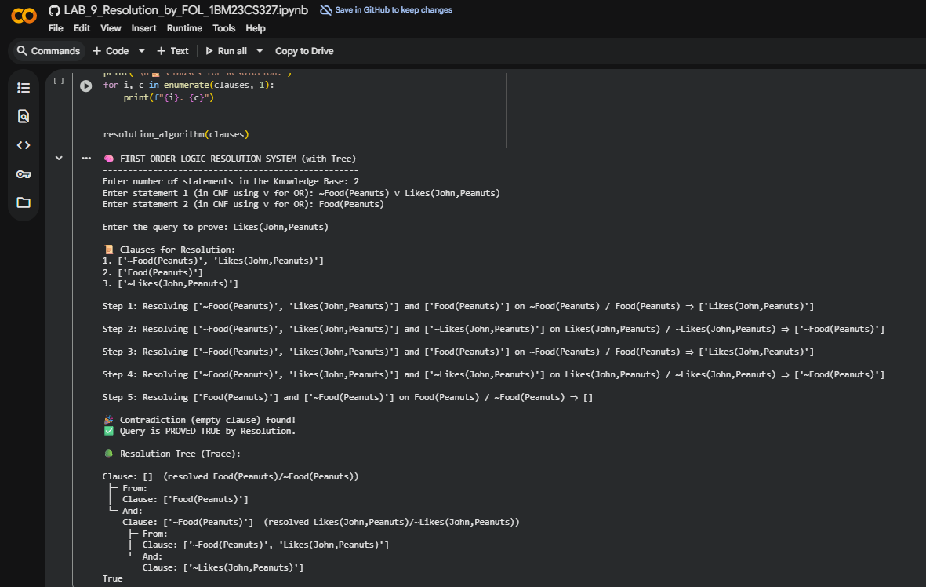

**10. Implement Alpha-Beta Pruning.**

Algorithm:

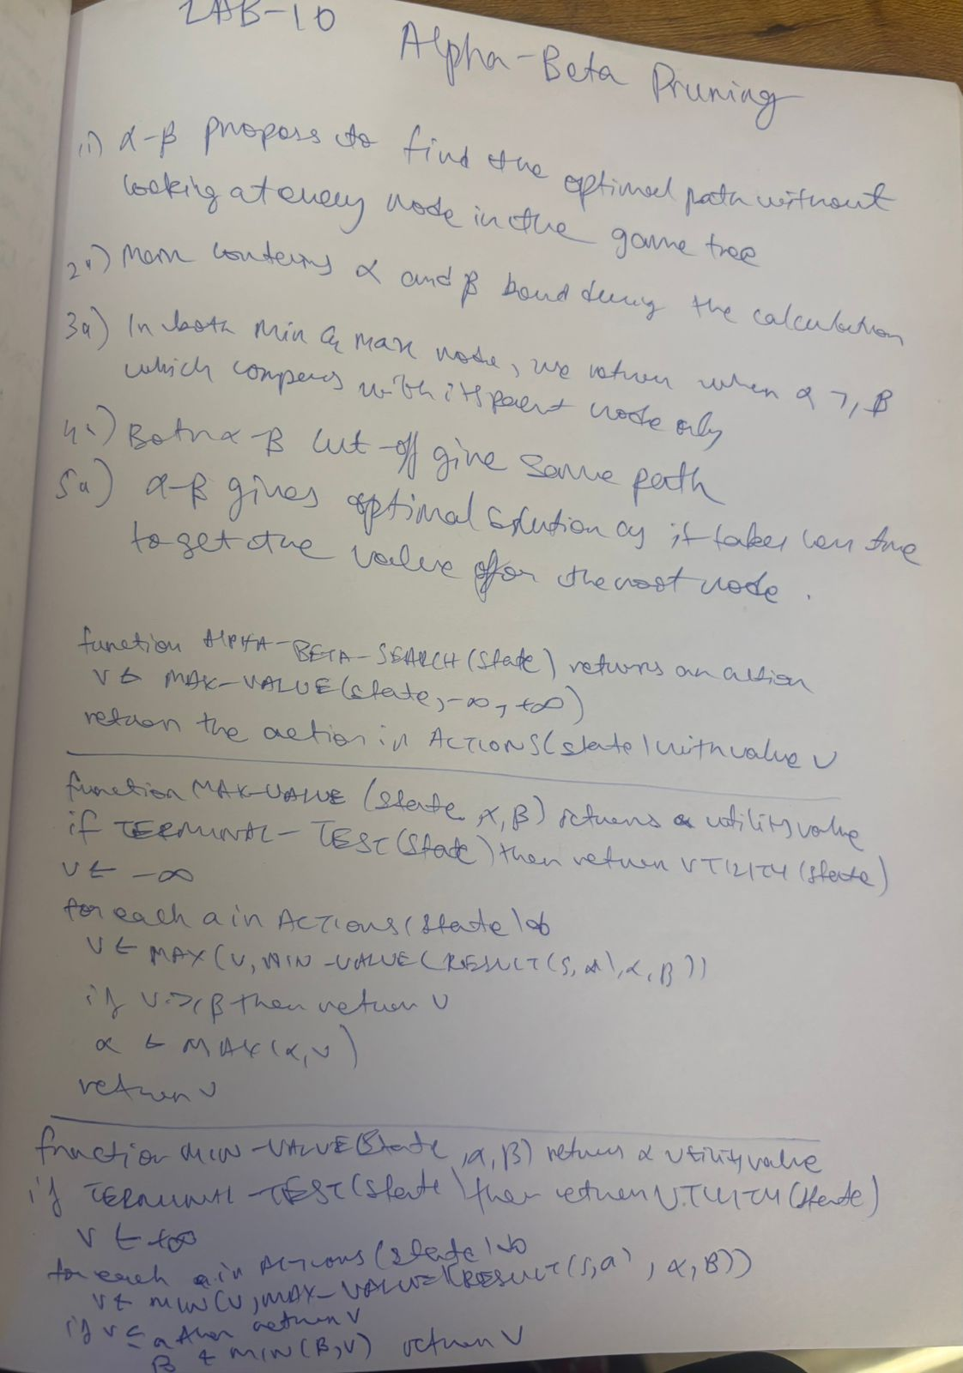

Code & Output:

